Supplemental data
Materials and methods
In supplemental experiment 1, overnight-fasted mice were divided into three groups (n = 8/group): DF-free, cellulose, and lignin groups. The mean and standard deviation of the body weight and fasting blood glucose concentration were counterbalanced among groups. Mice in each group were individually fed a DF-free diet, a diet containing cellulose, or a diet containing lignin (Supplemental Table 1), with each diet containing the same quantity of dietary fiber as in a 3.83-kJ WB diet (Table 3). The dietary fiber content of steamed WB was based on reference 7 (i.e., 12.1% cellulose and 4.9% lignin). As described in Experiment 2, the experimental diets were fed to the mice and postprandial blood samples were collected.
The reduced arabinoxylan fraction (R-AX fraction) was prepared according to previously reported methods (J of Food Composition and Analysis. 2011; 24: 1057-63). Briefly, steamed wheat bran was washed with hexane, ethanol, and distilled water. The resulting residue was extracted with 1.0 M HCl aq. The extract was neutralized to pH 8.0 with NaOH aq. to form the precipitate (precipitate A). Precipitate A was collected after centrifugation, and the supernatant was further precipitated by adding an equivalent volume of ethanol. The resulting precipitate (precipitate B) was collected after centrifugation. The mixture of precipitates A and B (R-AX fraction) was analyzed for its components and examined as described in the main text. The amount of arabinoxylan and phytic acid of R-AX fraction was determined as described in the main text. The protein content was measured using a Protein Assay Rapid Kit Wako (Wako Pure Chemical Industries, Osaka, Japan). In supplemental experiment 2, overnight-fasted mice were divided into two groups (n = 8/group): DF-free and R-AX groups. The mean and standard deviation of the body weight and fasting blood glucose concentration were counterbalanced among groups. Mice in each group were individually fed a DF-free diet or a diet containing R-AX fraction (Supplemental Table 1). As described in Experiment 2, the experimental diets were fed to the mice and postprandial blood samples were collected.
Supplemental TABLE 1. Nutrient content of the diets.
Ingredients (mg/g diet) | DF-free diet | Cellulose-diet | Lignin-diet | R-AX diet
Gelatinized potato starch | 510 | 489 | 502 | 473
Sucrose | 130 | 125 | 128 | 121
Corn oil | 97 | 93 | 95 | 90
Milk casein | 218 | 209 | 214 | 202
AIN-76 mineral mixture | 35 | 33 | 34 | 32
AIN-76 vitamin mixture | 10 | 10 | 10 | 9
Cellulose | 0 | 41 | 0 | N.D.
Lignin  R-AX fraction | 0  0 | 0  0 | 17  0 | N.D.  73
Arabinoxylan | 0 | 0 | 0 | 3.1
Total energy (kJ/g) | 18.0 | 17.2 | 17.6 | 16.7
Fat (% energy) | 20.3 | 20.3 | 20.3 | 20.3
Protein (% energy) | 20.3 | 20.3 | 20.3 | 20.3
Carbohydrates (% energy) | 59.4 | 59.4 | 59.4 | 59.4

Supplement TABLE 2. Composition of the R-AX fraction.
Components (%) | fraction
Arabinose/Xylose | 4.3
Phytic acid | 18.8
Protein | 0.7
Others | 76.2

Supplemental Figure 1. Effects of cellulose and lignin on postprandial blood variables.
Plasma concentrations at the indicated times after the feeding (A, C, and E) and incremental area under the curve (iAUCs; B, D, and F) of (A, B) total GIP, (C, D) insulin, and (E, F) glucose in mice fed the DF-free diet (DF-free; open circles), diet containing cellulose (Cell; empty squares), or diet containing lignin (Lig; filled triangles). All data are presented as the mean ± standard error (SE). Time-dependent changes were compared using a two-way ANOVA to evaluate the diet-by-time interaction (D × T), the time effect (T), and the diet effect (D). The iAUCs of total GIP, insulin, and glucose were evaluated using the Bonferroni post hoc test (vs. DF-free) after one-way ANOVA.

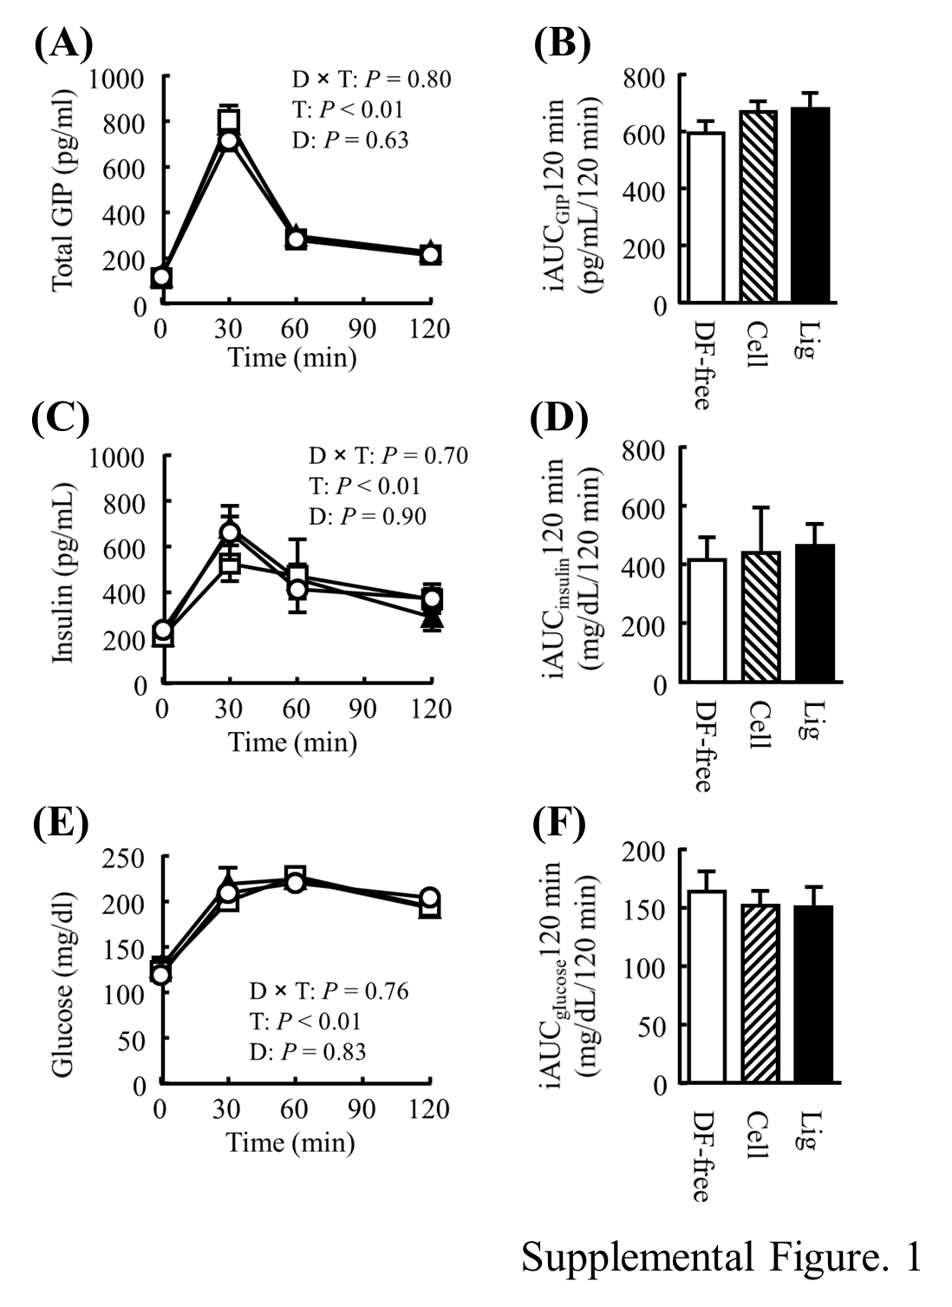

Supplemental Figure 2. Effects of the R-AX fraction on postprandial blood variables.
Plasma concentrations at the indicated times after the feeding (A, C, and E) and incremental area under the curve (iAUCs; B, D, and F) of (A, B) total GIP, (C, D) insulin, and (E, F) glucose in mice fed the DF-free diet (DF-free; open circles) or diet containing the R-AX fraction (R-AX; filled circles). All data are presented as the mean ± standard error (SE). Time-dependent changes were compared using a two-way ANOVA to evaluate the diet-by-time interaction (D × T), the time effect (T), and the diet effect (D). The iAUCs of total GIP, insulin, and glucose were evaluated using a t-test.

