Supplementary materials

Table S1 Ratio of each component of the HFD 32
Components | %
Milk casein | 24.500
Albumen powder | 5.000
L-Cystin | 0.430
Beef tallow powder  (Contains 80% beef tallow) | 15.880
Safflower oil (High oleic acid type) | 20.000
Crystalline cellulose | 5.500
Maltodextrin | 8.250
Lactose | 6.928
Sucrose | 6.750
AIN93 vitamin mix | 1.400
AIN93 mineral mix | 5.000
Choline bitartrate | 0.360
3- Butyl hydroxynon | 0.002
Total | 100.000

Table S2 Specific primer sequences of lipid metabolism-related genes
Genes | Forward | Reverse
Gapdh | AGAACATCATCCCTGCATCCA | CCGTTCAGCTCTGGGATGAC
Srebp1c | GGAGCCATGGATTGCACATT | CCTGTCTCACCCCCAGCATA
Atgl | GGTGCCAACATTATTGAGGTG | AAACACGAGTCAGGGAGATGC
ap2 | CAAAATGTGTGATGCCTTTGTC | CTCTTCCTTTGGCTCATGCC
Cpt1 | CGGTTCAAGAATGGCATCATC | ATCACACCCACCACCACGATA
Ucp1 | TACAGAGTTATAGCCACCACCACA | TGGAACGTCATCATCATGTTTGTG
Aco | CCCAAGACCCAAGAGTTCATTC | CACGGATAGGGACAACAAAGG
Mcad | TGTGCCTACTGCGTGACAGA | TTCATCACCCTTCTTCTCTGCTT
Ppara | TGGAGTCCACGCATGTGAAG | TGTTCCGGTTCTTTTTCTGAATCT
Fabp4 | CAAGCCCAACATGATCATGAGC | CACGCCCAGTTTGAAGGAAATC
Tnfa | AAATGGGCTCCCTCTCATCAGTTC | TCTGCTTGGTGGTTTGCTACGAC
I16 | CAGTGTCATGGTTCCTTTGC | CACCGAGGAACTACCTGAT
I11b | CACCTCTCAAGCAGAGCACAG | GGGTTCCATGGTGAAGTCAAC
Adiponectin | CAGAATTCATTATGACGGCAGCAC | AGACTTGGTCTCCCACCTCCA
Leptin | GACATTTCACACAGGCAGTCG | GCAAGCTGGTGAGGATCTGT

Table S3 Organ and tissue weights in HFD-fed obese SD rats for 8 weeks under Control or Mate supplementation.
Organ and tissue | Control  (mg/g (body weight)) | Mate  (mg/g (body weight))
Liver | 27.7±0.95 | 23.3±0.70**
Kidneys | 4.83±0.11 | 4.66±0.07
Spleen | 1.55±0.02 | 1.56±0.10
Heart | 2.16±0.03 | 2.16±0.07
EAT | 24.6±2.63 | 24.8±2.76
PAT | 32.2±3.10 | 40.9±1.64
Brain | 2.54±0.05 | 2.67±0.02*
Mate (0.5 g/kg body weight/day) decreased the weight of the liver and brain in HFD-fed obese SD rats. The table shows the weights of the liver, kidneys, spleen, heart, EAT, PAT, and brain. The data are represented as means ± S.E.M. (n = 10, 10, 8 respectively), *P < 0.05, **P < 0.01 vs. the Control group.

Fig. S1 Pathway associated with the improvement of lipid metabolism in the EAT of HFD-diet fed obese SD rats for 8 weeks under Control or Mate (0.5 g / kg body weight / day) supplementation.
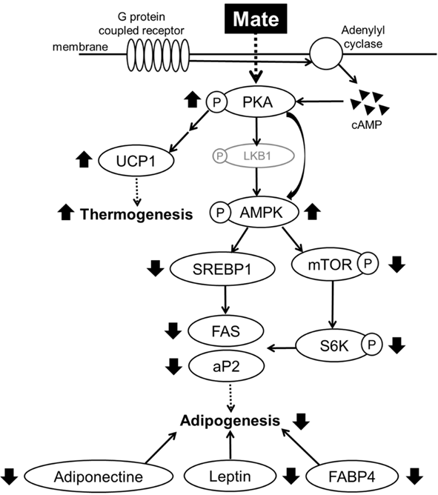

Fig. S2 Pathway associated with the suppression of intracellular lipid accumulation in MDI-induced 3T3-L1 adipocytes for 7 d under Control or Mate (10, 50, 100 µg/mL) supplementation.

