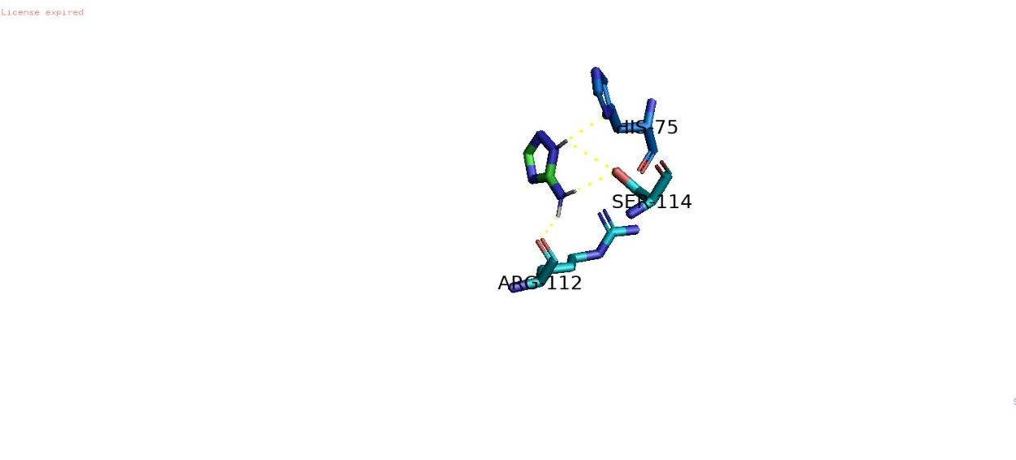
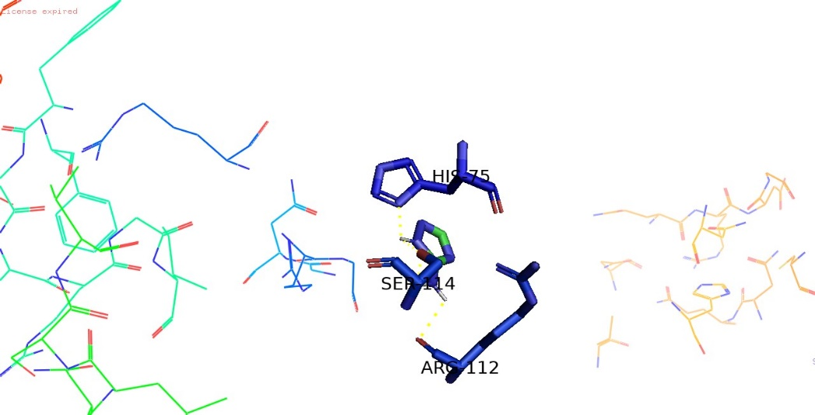
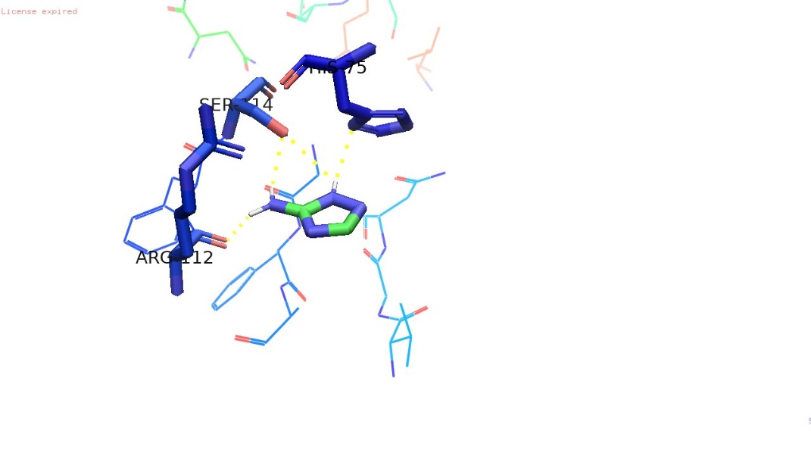
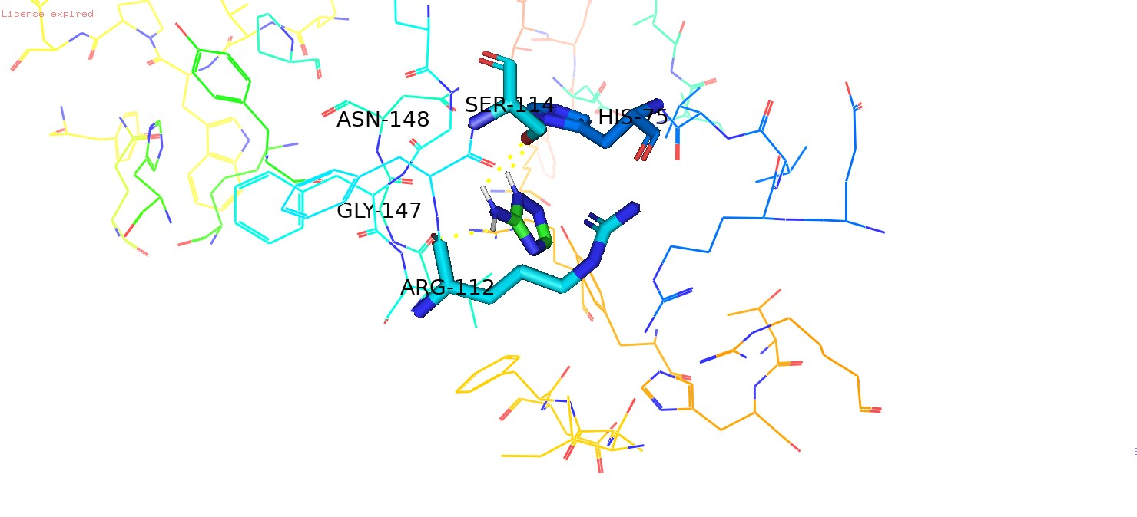
Chain A
Chain B
Chain C
Chain D

Figure A: Amitrole showing similar binding patterns of HIS-75, SER-114 and ARG-112 across all chains, interacting with corresponding conserved residues in the active sites of chains A and C as it does with chains B and D.

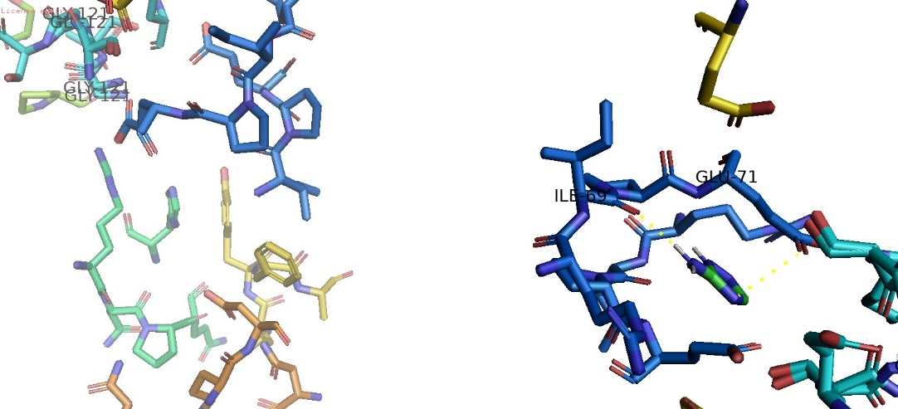
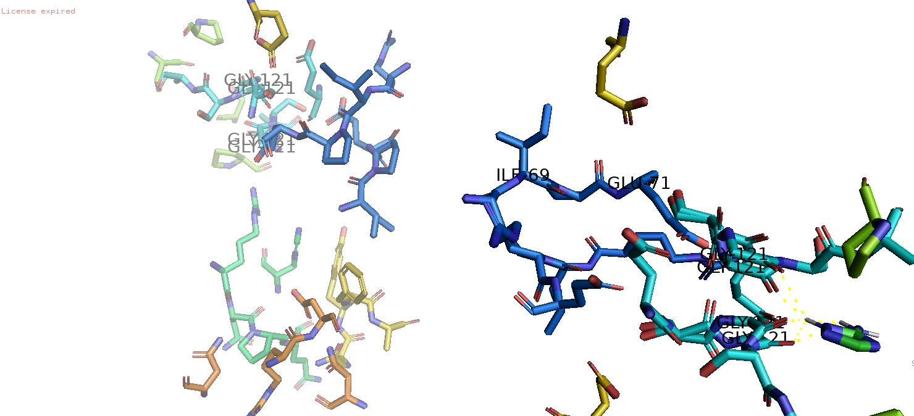

Figure B: Amitrole showing similar binding patterns in tetrameric chains. On docking first position Amitrole binds with ILE-69 and GLU-71 and on the 2nd position binds with GLY121.

