Female Balb/c mice
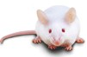
Fed with vitamin D deprived chow (VD-) or control chow (SC)

6 weeks

♀ × ♂
Mating with SC- fed male mice
F0
Pregnant mice (SC)
Pregnant mice (VD-) (VD-)

SC chow
(VD-/SC)
VD-chow
(VD-/VD-)

SC chow
(SC/SC)
VD- chow
(SC/VD-)
F1
3 weeks

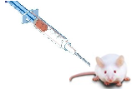
Allergic reactions of offspring were induced at the age of 6 weeks
Vitamin D deficiency in pregnancy & early life

Allergic symptoms
OVA-IgE, IL-4 levels
Severity of disruption of small intestinal villi
The percentages of CD4⁺CD25⁺ Foxp3⁺Treg cell
Expressions of the tight junction protein

