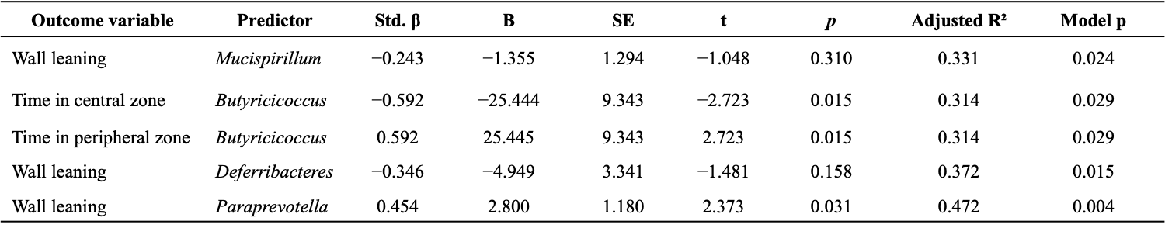
Multiple linear regression models were adjusted for maternal diet and methyl donor supplementation. Std. β represents standardized regression coefficients. Significant associations are indicated in bold.
Supplementary Table S1. Adjusted linear regression models evaluating microbiota - behavior associations in offspring

