Table S1: Primary and secondary antibody details
S. No. | Antibody | Cat. No. | Type | Reactivity | Mol Weight (kDa) | Source | Manufacturer | Dilution
1 | Phospho-mTOR (Ser2448) | 2971S | Primary | H M R Mk | 289 | Rabbit Polyclonal | Cell Signaling Technology, Danvers, MA | 1:1000
2 | mTOR | 2983S | Primary | H M R Mk | 289 | Rabbit Monoclonal | Cell Signaling Technology, Danvers, MA | 1:1000
3 | Phospho-AKT (Ser473) | 9271S | Primary | H M R Hm Mk B Dg | 60 | Rabbit Polyclonal | Cell Signaling Technology, Danvers, MA | 1:1000
4 | AKT | 9272S | Primary | H M R Hm Mk C B Dg Pg GP | 60 | Rabbit | Cell Signaling Technology, Danvers, MA | 1:1000
5 | Phospho-eNOS (Ser1177) | 9571S | Primary | H B Pg | 140 | Rabbit | Cell Signaling Technology, Danvers, MA | 1:1000
6 | eNOS | 9572S | Primary | H B Pg | 140 | Rabbit | Cell Signaling Technology, Danvers, MA | 1:1000
7 | Phospho-FOXO3a (Ser253) | 9466S | Primary | H M R | 97 | Rabbit | Cell Signaling Technology, Danvers, MA | 1:1000
8 | FOXO3a | 2497S | Primary | H M R Mk | 82 to 97 | Rabbit IgG | Cell Signaling Technology, Danvers, MA | 1:1000
9 | BAX | 2772S | Primary | H M R Mk | 20 | Rabbit | Cell Signaling Technology, Danvers, MA | 1:1000
10 | Bcl-2 | 2876S | Primary | H M R | 28 | Rabbit | Cell Signaling Technology, Danvers, MA | 1:1000
11 | Caspase-3 | 9662S | Primary | H M R Mk | 17, 19, 35 | Rabbit | Cell Signaling Technology, Danvers, MA | 1:1000
12 | PARP | 9542S | Primary | H M R Mk | 89, 116 | Rabbit | Cell Signaling Technology, Danvers, MA | 1:1000
13 | Phospho-p70 S6 Kinase (Thr389) | 9205S | Primary | H M R Mk | 70, 85 | Rabbit | Cell Signaling Technology, Danvers, MA | 1:1000
14 | p70S6 Kinase | 2708S | Primary | H | 70, 85 | Rabbit IgG | Cell Signaling Technology, Danvers, MA | 1:1000
15 | Phospho-PI3 kinase p85 alpha/gamma (Tyr467, Tyr199) | BS-3332R | Primary | H R | 120 | Rabbit Polyclonal | Bioss Antibodies Woburn, MA | 1:1000
16 | PI3K | BSM-33219 | Primary | H M R C | 80 | Mouse Monoclonal | Bioss Antibodies Woburn, MA | 1:1000
17 | Phospho-LDHA (Tyr10) | PA5-105445 | Primary | H | 37 | Rabbit Polyclonal | Thermo Fisher Scientific, Altham, MA | 1:1000
18 | LDH | PA5-27406 | Primary | H M R | 37 | Rabbit Polyclonal | Thermo Fisher Scientific, Altham, MA | 1:1000
19 | MyoD | MAB3878 | Primary | Ch, H, M, R | 45 | Mouse Monoclonal | Merck Millipore, Darmstadt, Germany | 1:1000
20 | Myogenin | MAB3876 | Primary | H M R | 34 | Mouse Monoclonal | Merck Millipore, Darmstadt, Germany | 1:1000
21 | Myf-6 | SC-301 | Primary | H M R | 30 | Rabbit Polyclonal | Santa Cruz Biotechnology, Santa Cruz, CA | 1:1000
22 | Atrogin-1/ ATR-1 | 3535-100 | Primary | H M R | 43 | Rabbit Polyclonal | Bio-vision, Milpitas, CA | 1:1000
23 | Murf-1/TRIM63 | AF5366 | Primary | H M R | 41 | Goat Polyclonal | R&D systems, Minneapolis, MN | 1:1000
24 | IGF-1 | 28530-1-AP | Primary | H M R C | 7.7 | Rabbit Polyclonal | Protein Tech, San Diego, CA | 1:500
25 | GDF8/Myostatin | 19142-1-ap | Primary | H M R | 26 | Rabbit Polyclonal | Protein Tech, San Diego, CA | 1:1000
26 | Anti- β-Actin Antibody | A2228-100UL | Primary | H M R | 42 | Mouse Monoclonal | Sigma-Aldrich, St. Louis, MO | 1:10000
27 | Peroxidase Affinipure Mouse anti-goat igG(H+L) | 205-035-108 | Secondary | H M Rb | NA | Anti-Goat | Jackson Immuno Research Laboratories, West Grove, PA | 1:10000
28 | Peroxidase Affinipure goat anti-rabbit igG(H+L) | 111-035-045 | Secondary | H | NA | Anti-Rabbit | Jackson Immuno Research Laboratories, West Grove, PA | 1:10000
29 | Peroxidase AffiniPure Goat Anti-Mouse IgG (H+L) | 115-035-062 | Secondary | H B Hr | NA | Anti-Mouse | Jackson Immuno Research Laboratories, West Grove, PA | 1:10000
Species Cross-Reactivity Key: H-Human, M-Mouse, R-Rat, Mk-Monkey, C-Chicken, B-Bovine, Dg-Dog, Pg-Pig, GP-Guinea pig, Hr-Horse

Figure S1
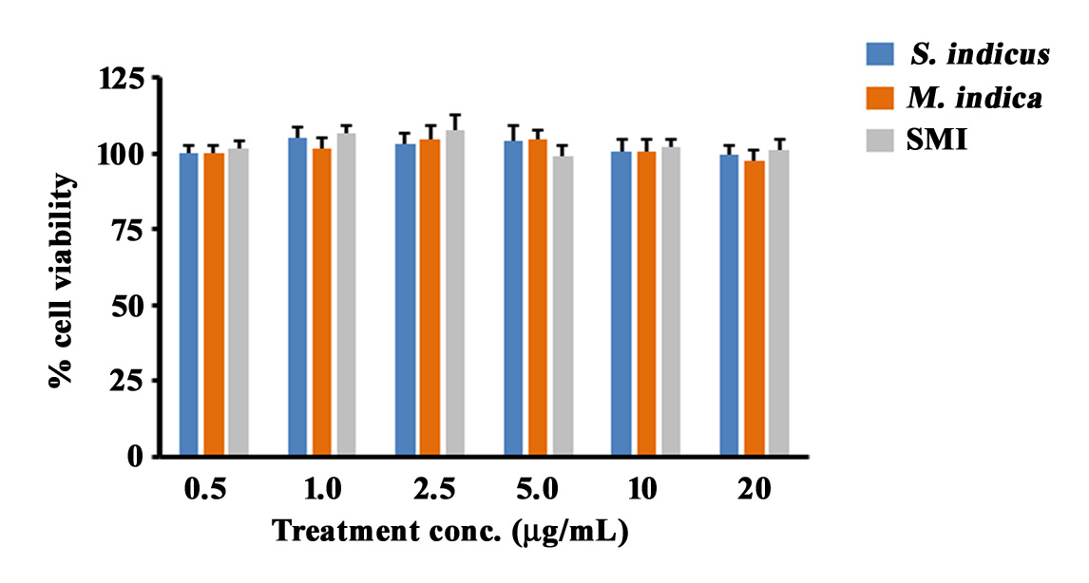

Figure S1. Effects of S. indicus, M. indica, and SMI on HL-60 cell viability. An equal number of HL-60 cells was treated with SI, MI, or SMI at concentrations ranging from 0.5 to 20 µg/mL for 24 hrs, as described in the Materials and Methods. Cell viability was assessed using the CCK-8 assay, and each bar represents the percentage of viable cells relative to vehicle-treated control (VC) cells. Data represent mean ± SD from three independent experiments, each performed in triplicate. Between-group comparison revealed no significant changes using an unpaired t-test.
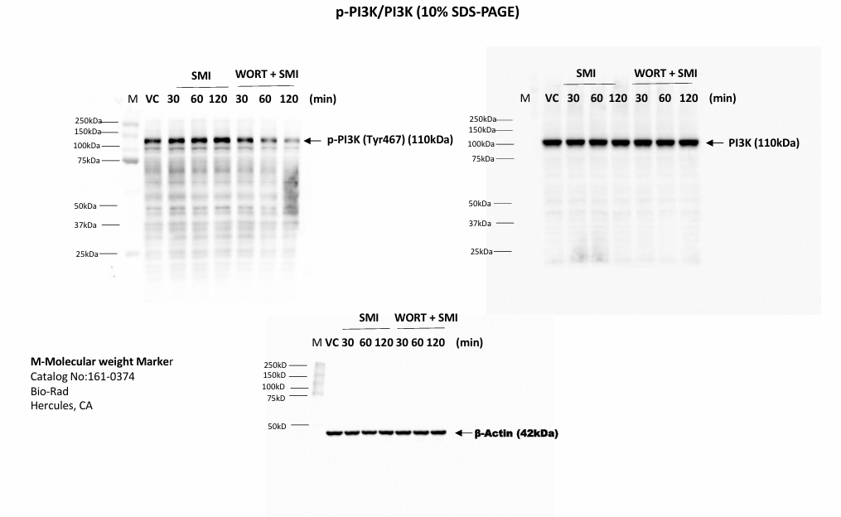
Fig 2C
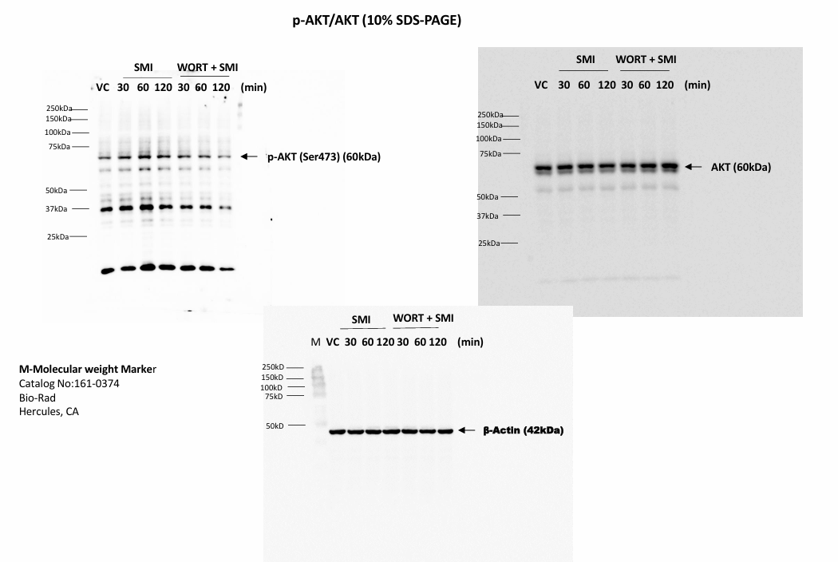
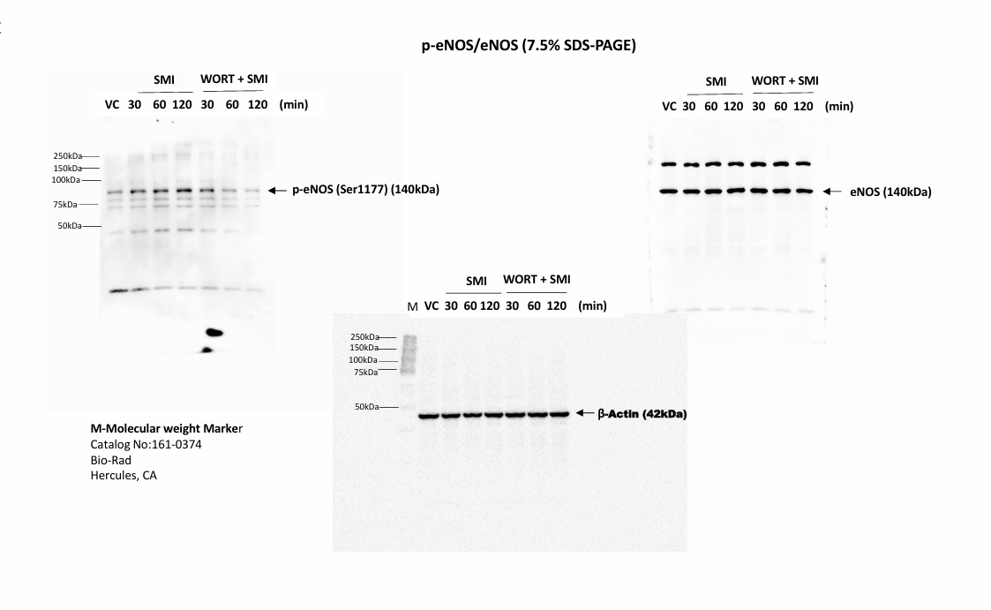
Fig 2C

Fig 2C
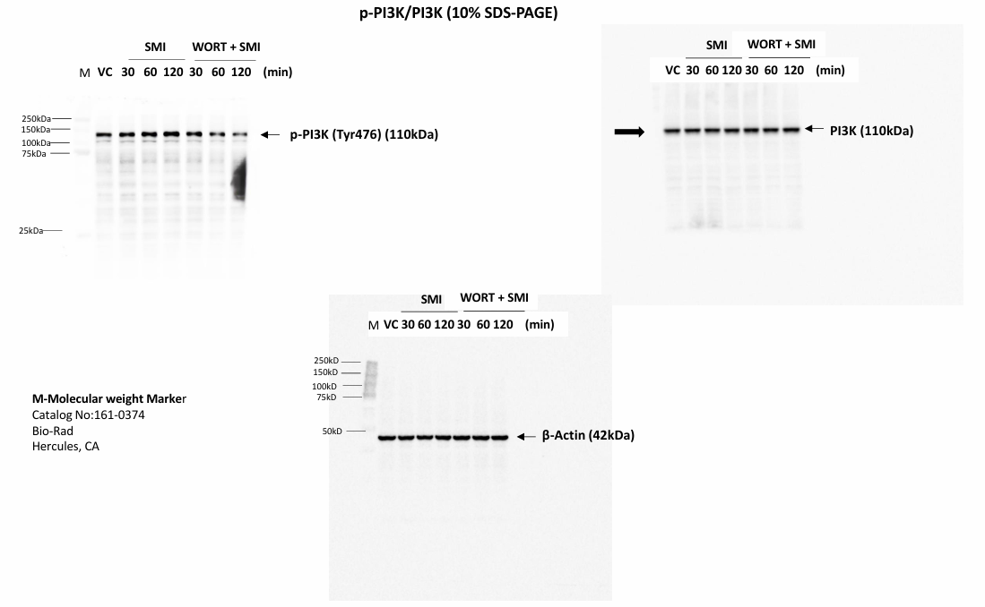
Fig 3A

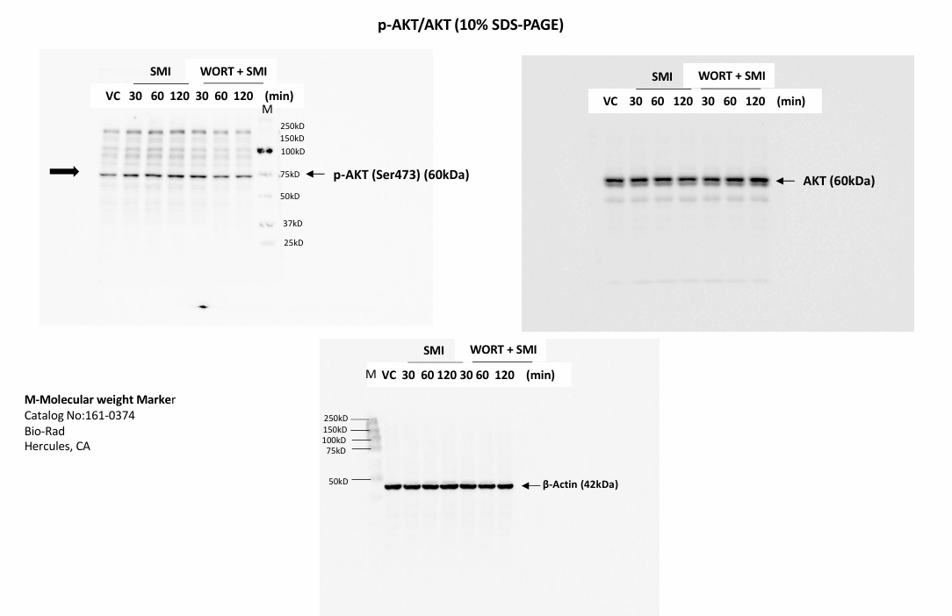
Fig 3A

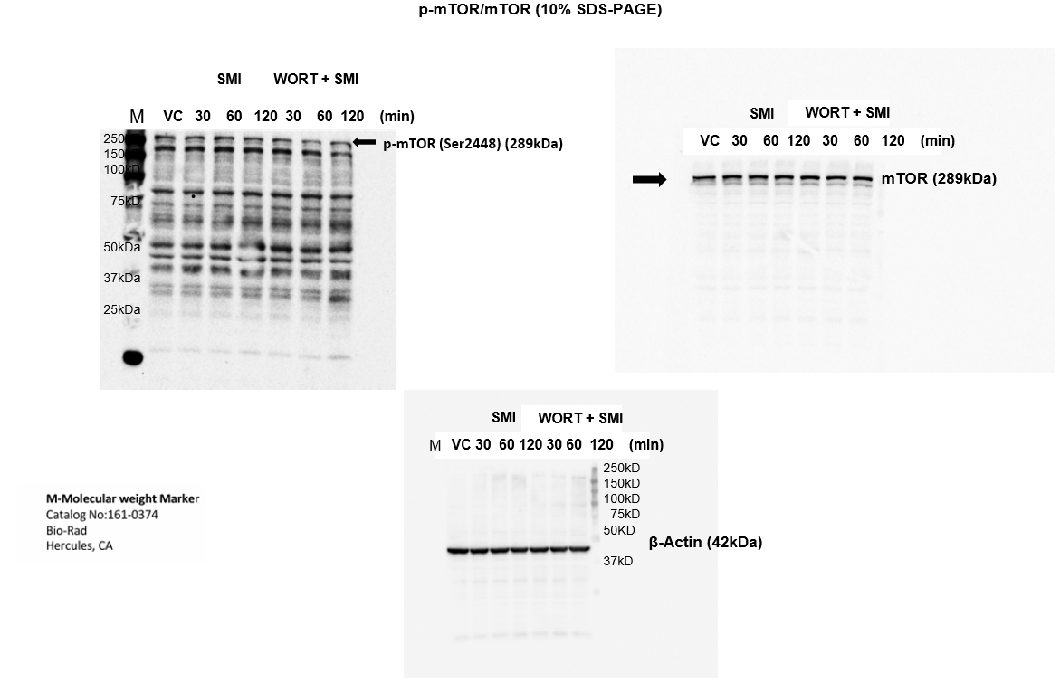
Fig3A
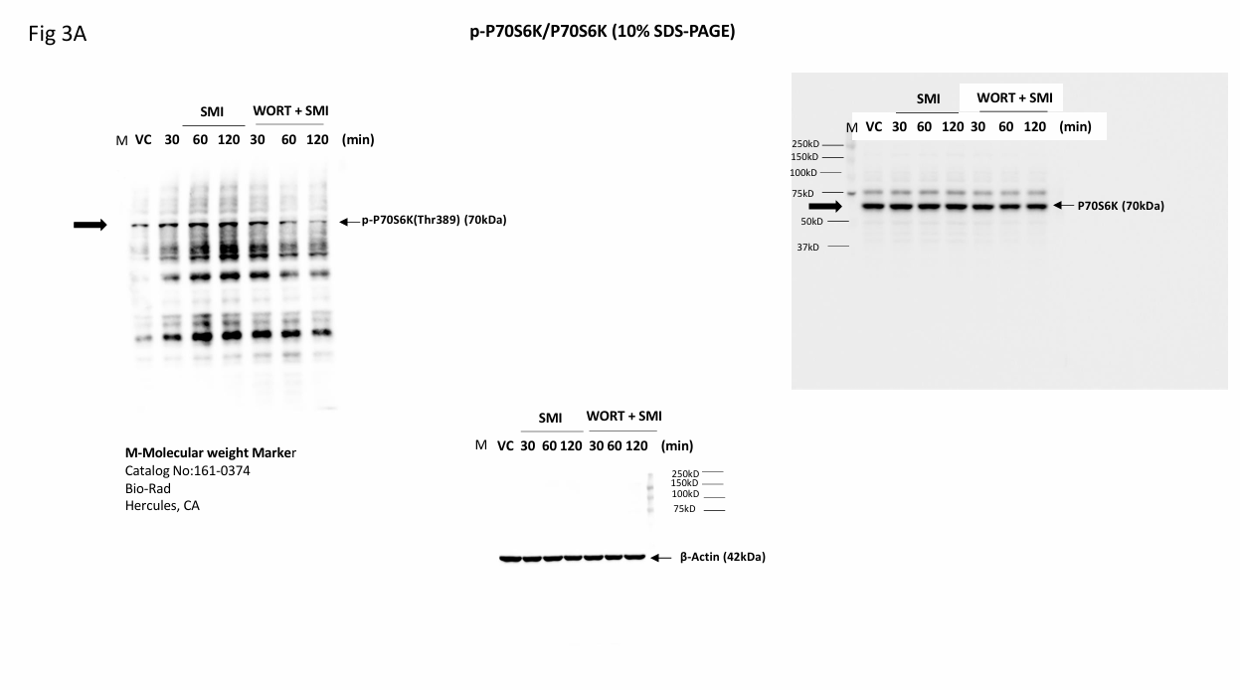
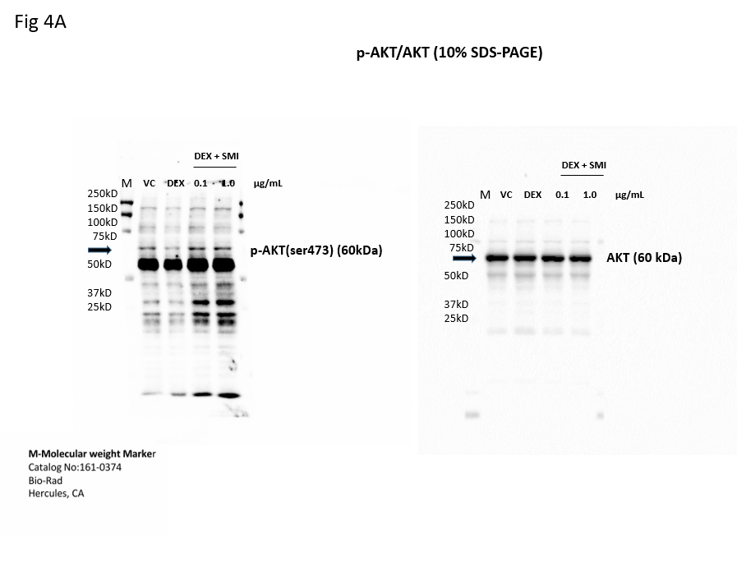
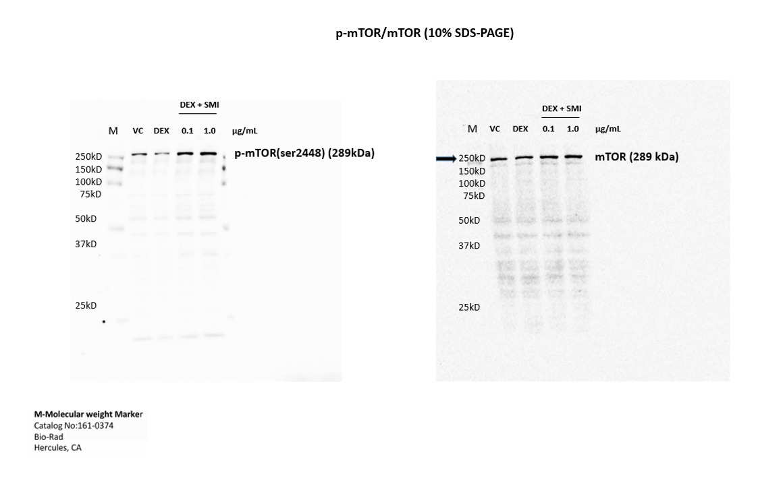
Fig 4A

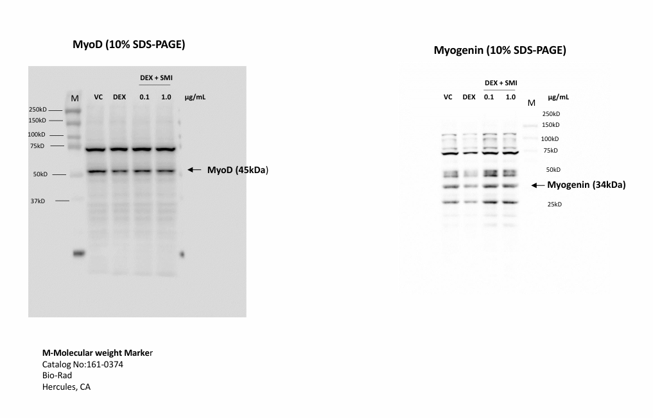
Fig 4A

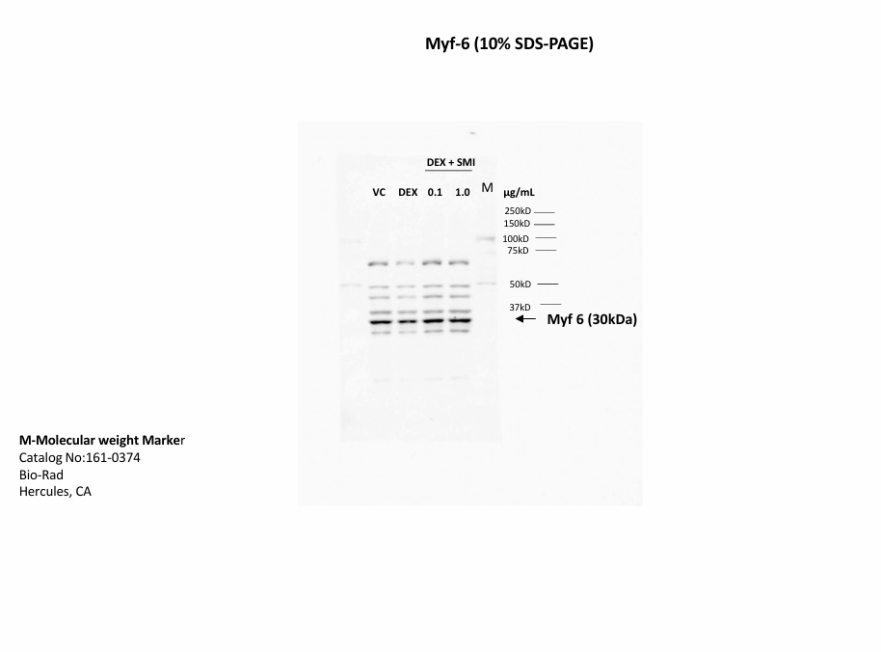
Fig 4A

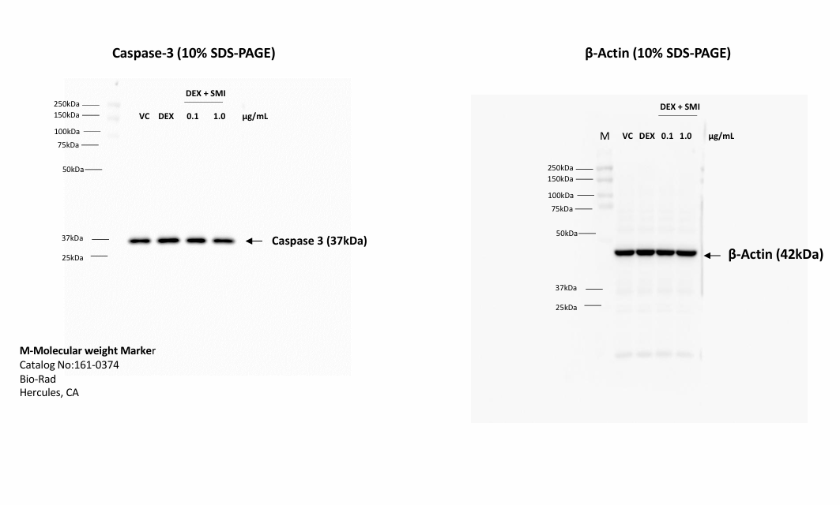
Fig 4B

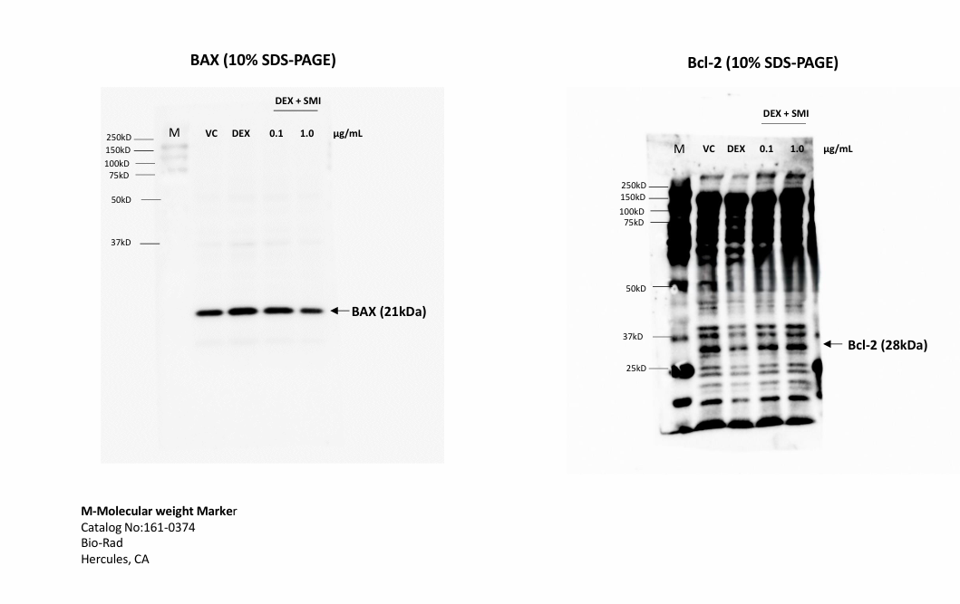
Fig 4B

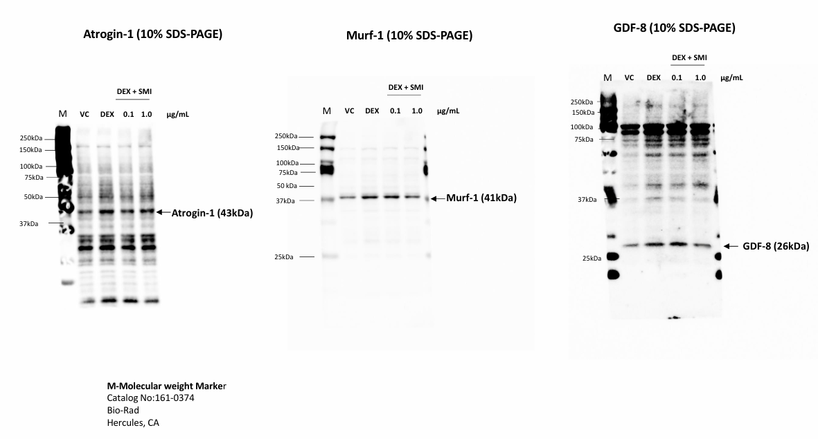
Fig 4B

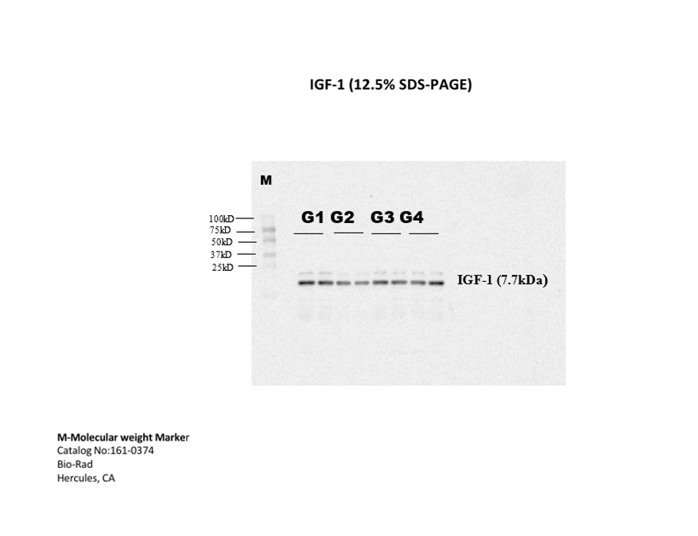
Fig 6A

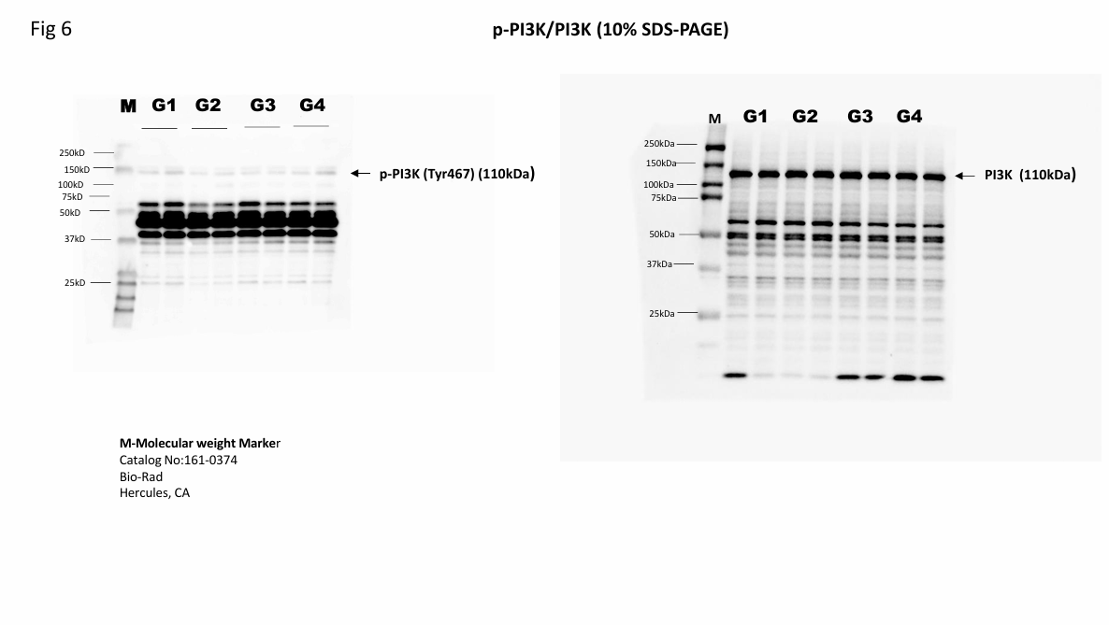
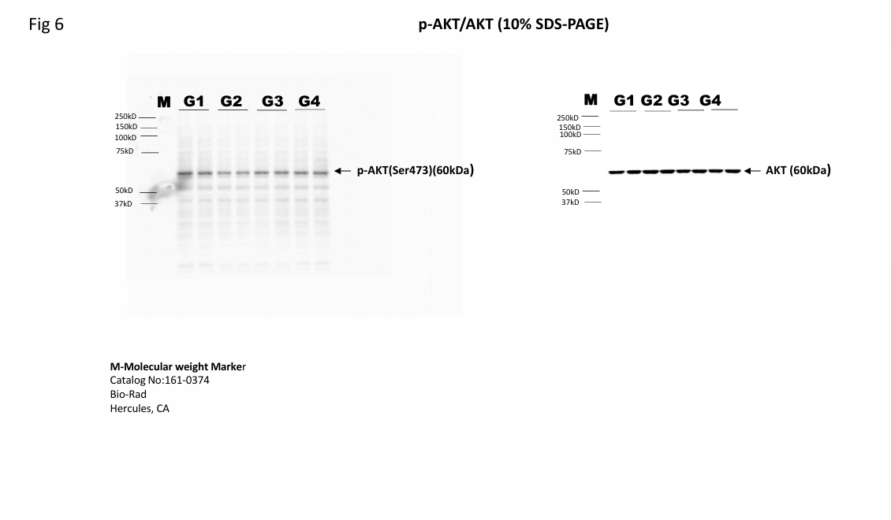
Fig 6A

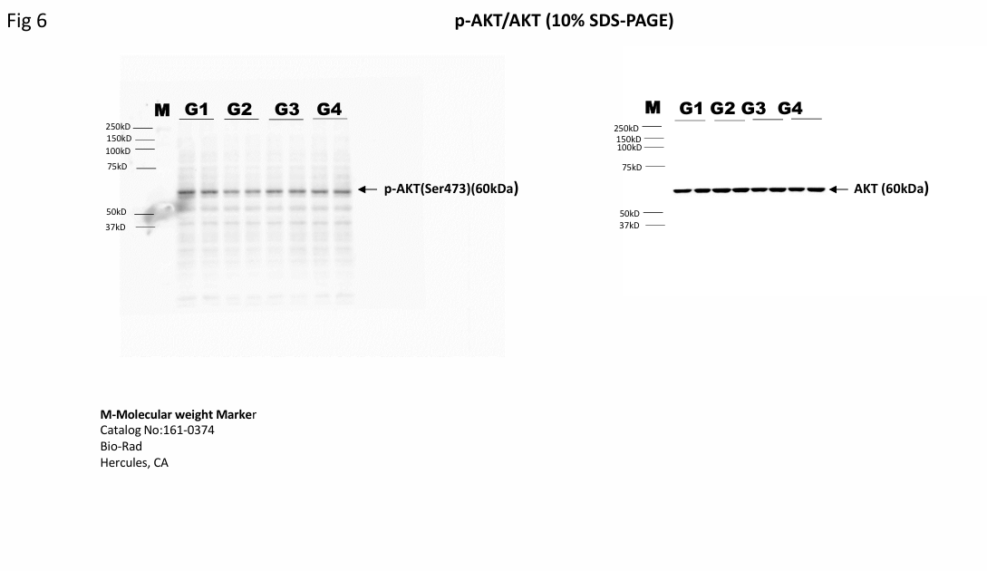
Fig 6A

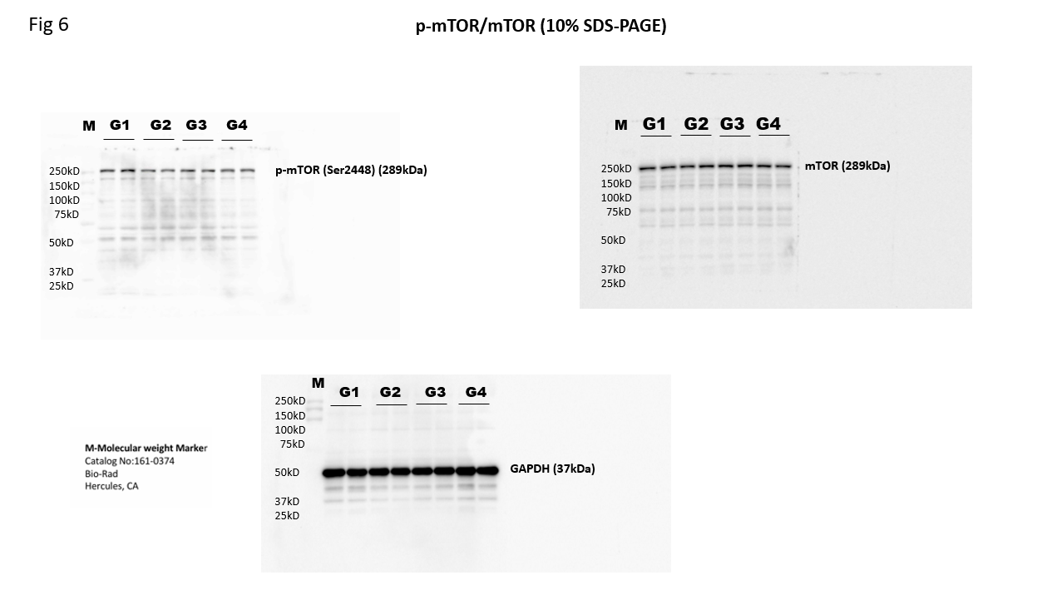
Fig 6A

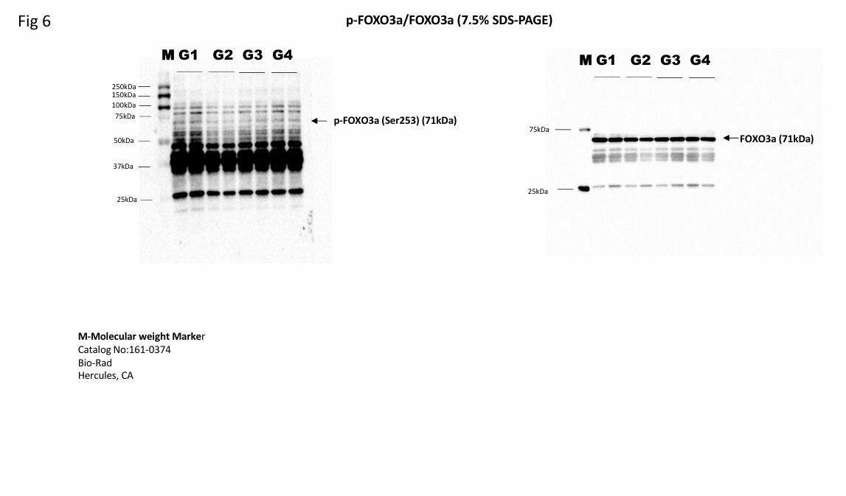
Fig 6A

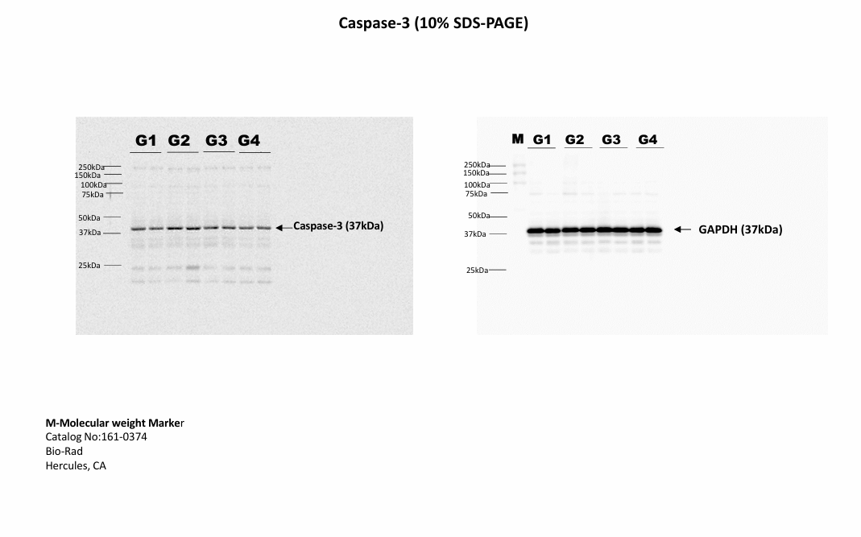
Fig 6A

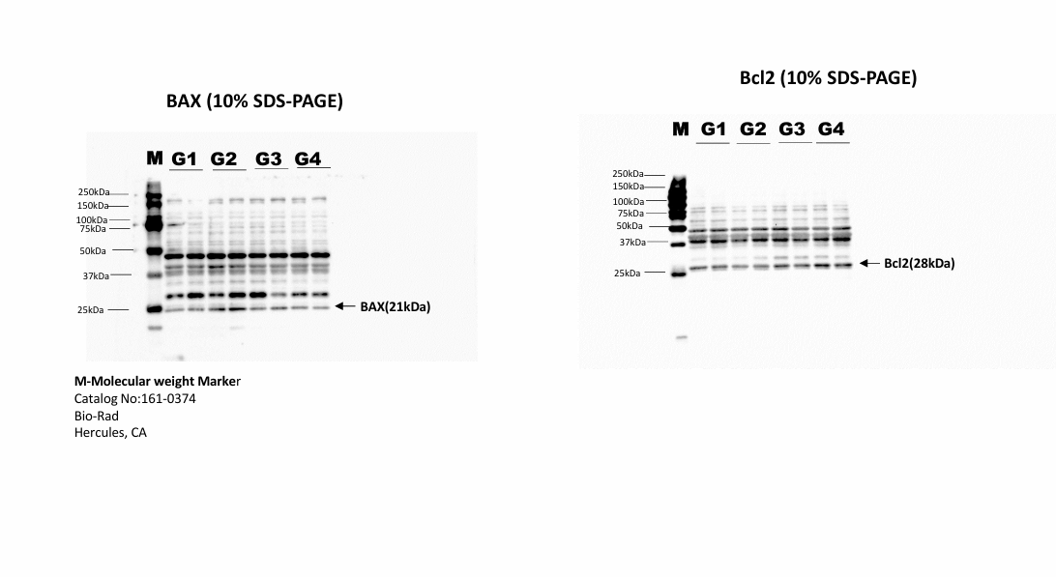
Fig 6A

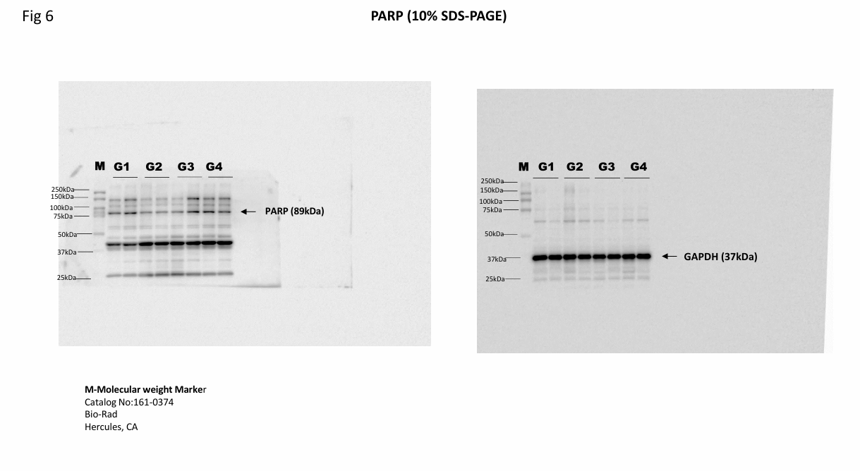
Fig 6B

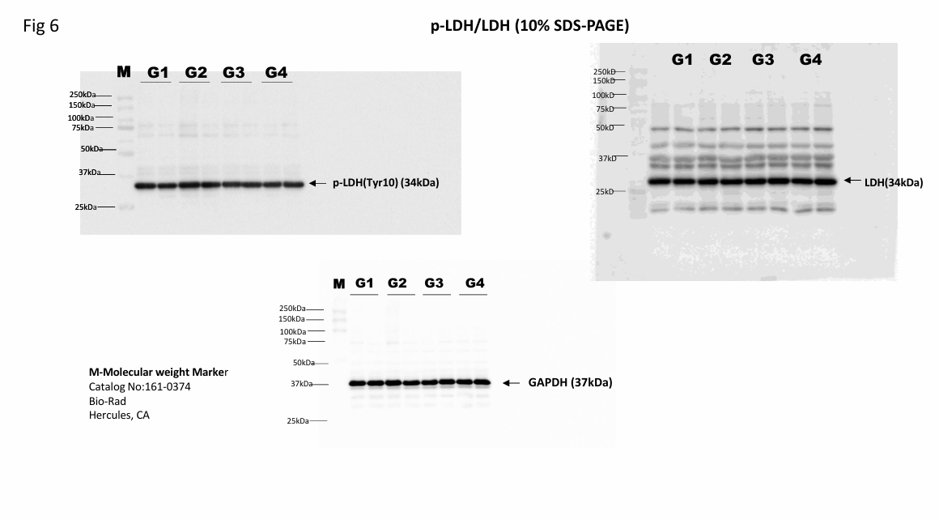
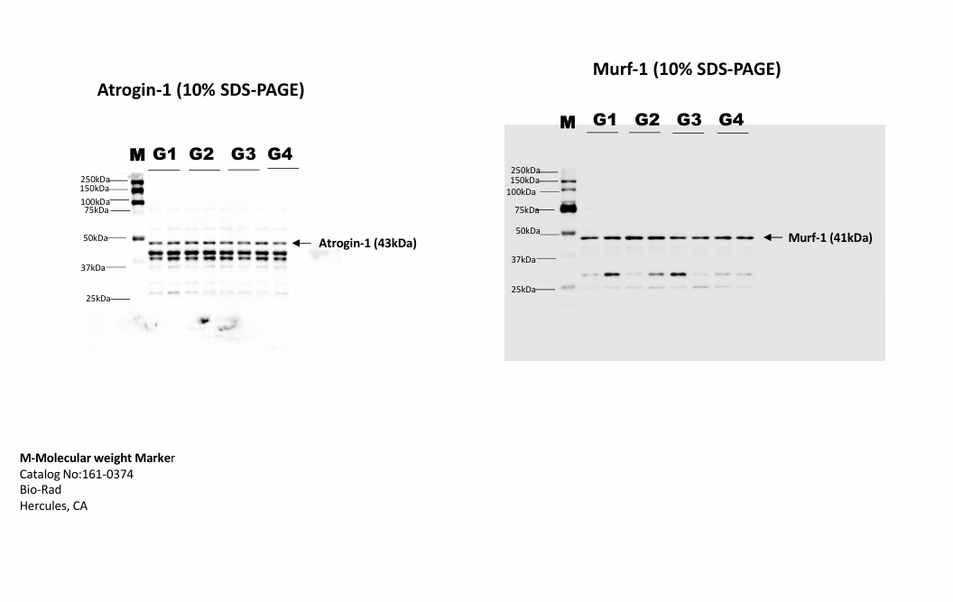
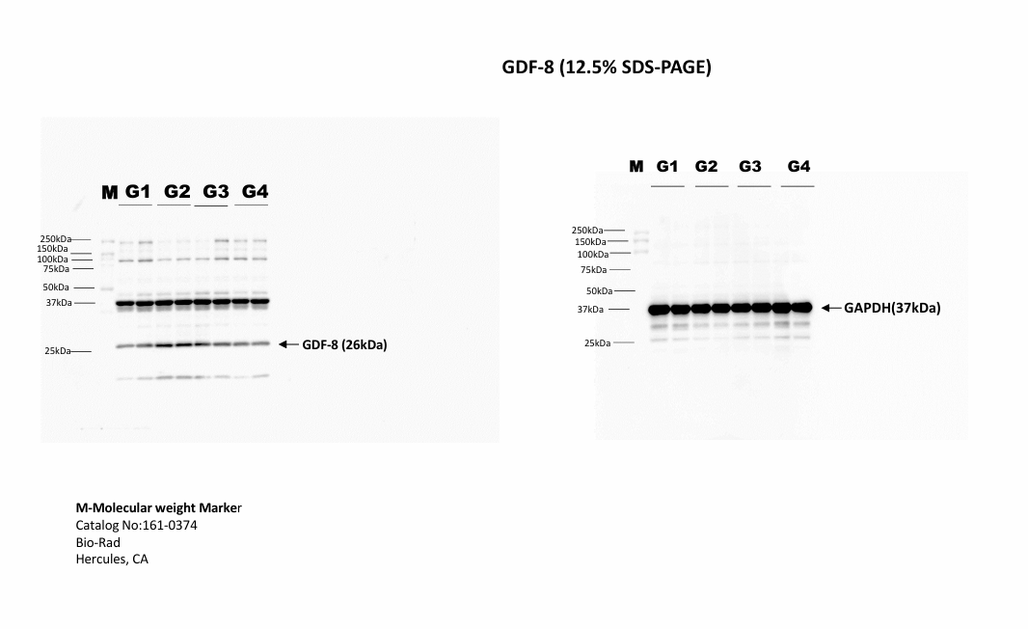
Fig 6B

Fig 6B

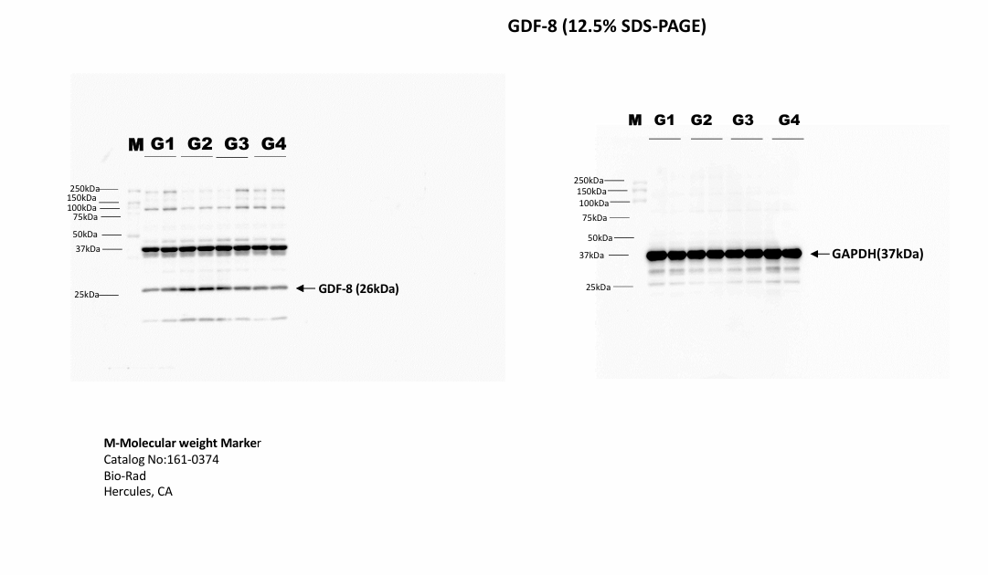
Fig 6B

