Supplemental data – L-arabinose
Figure S1 Delta over baseline of the 13C recovery in breath samples (n 15).
Data are means, with SEM represented by vertical bars.

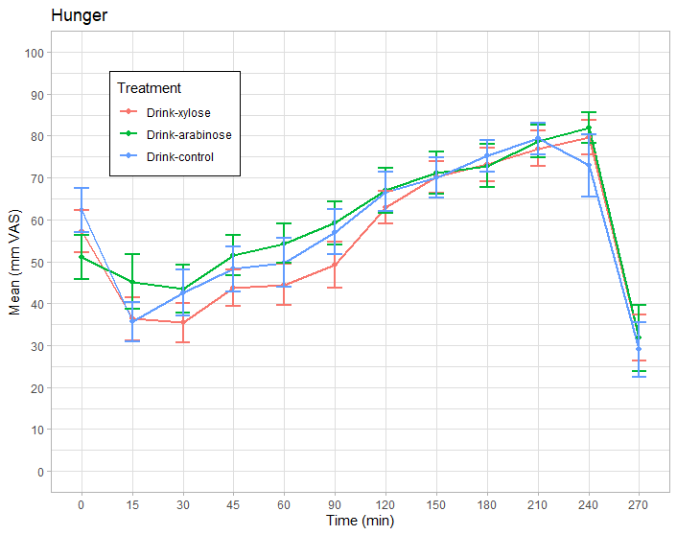 | 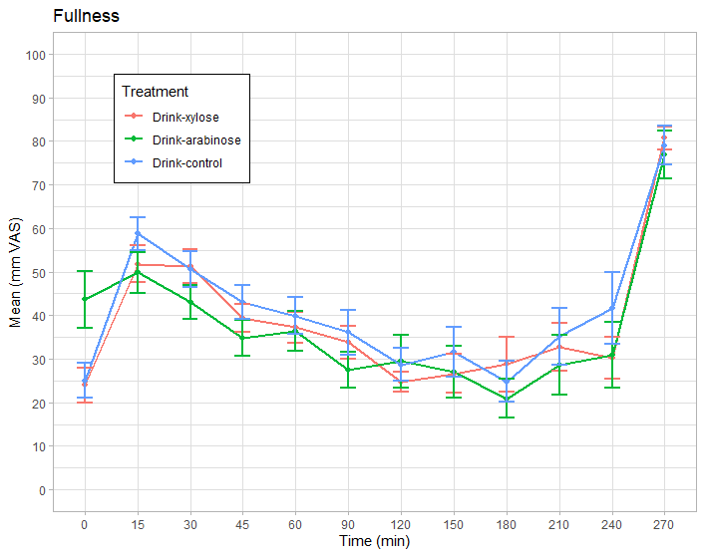
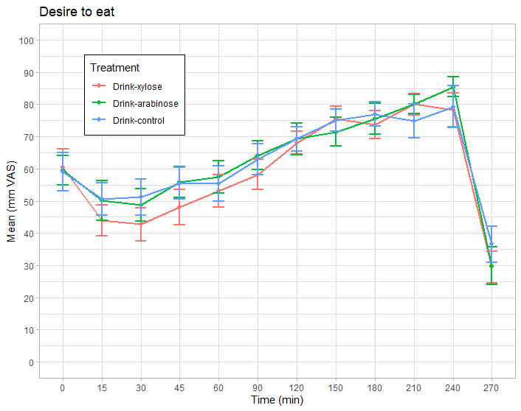 | 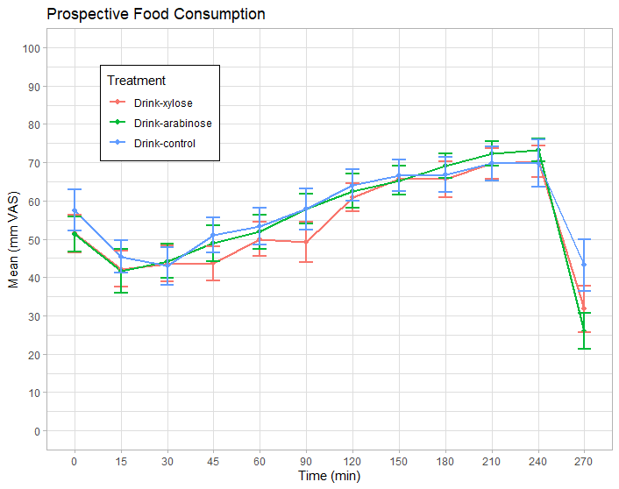
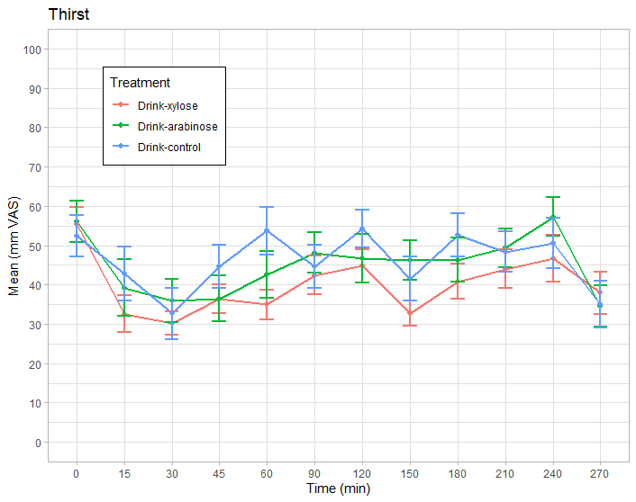 | 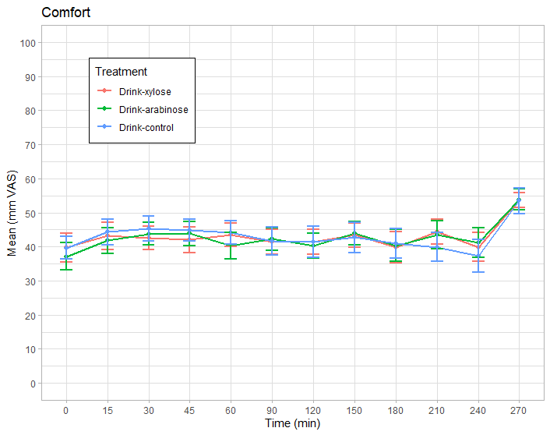
Figure S2. Subjective appetite feeling responses before and after consumption the drinks (n 15). At t=240 subjects received and ad libitum meal. Data are means, with standard errors represented by vertical bars.

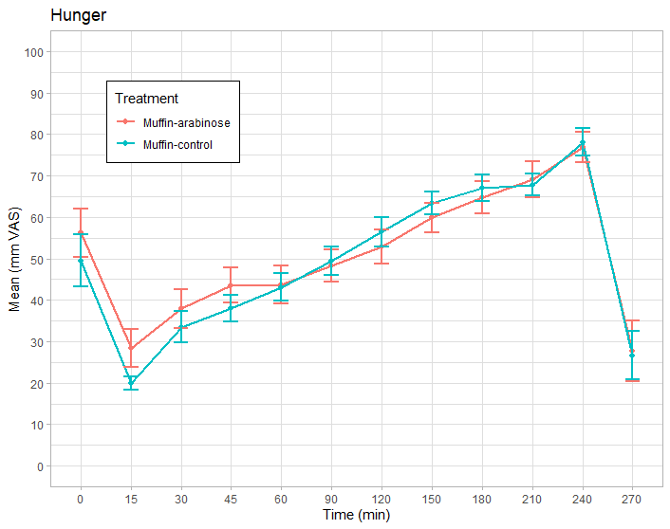 | 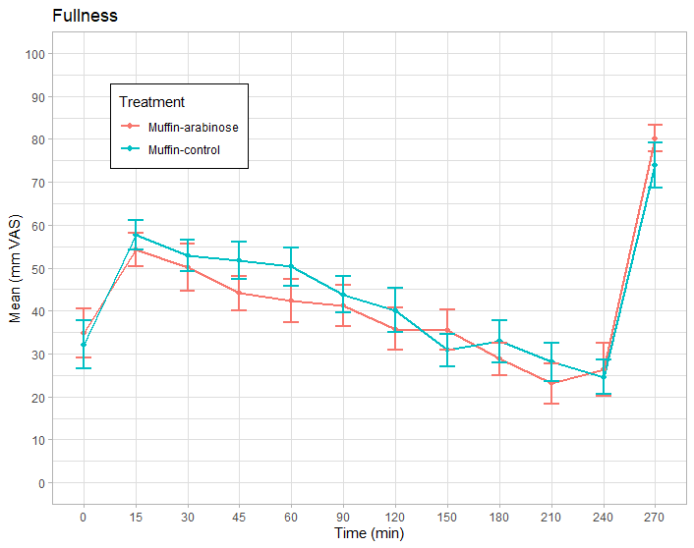
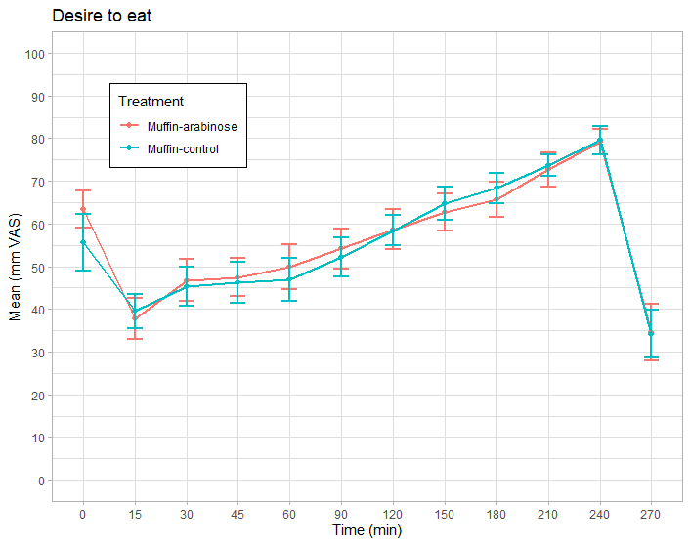 | 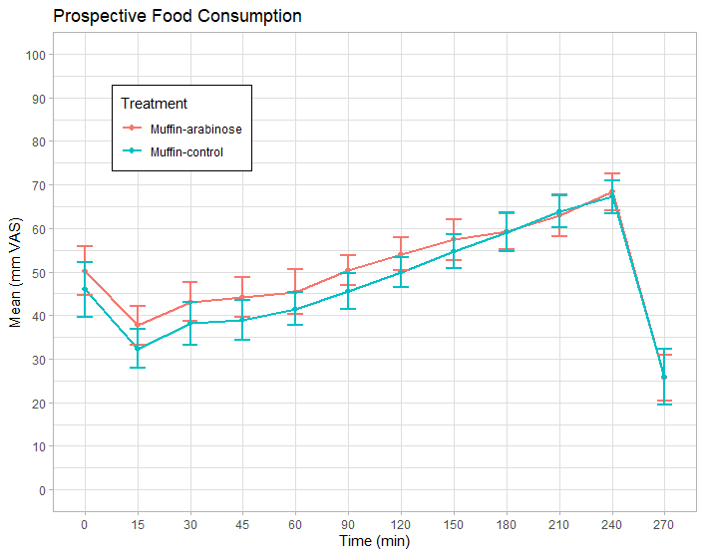
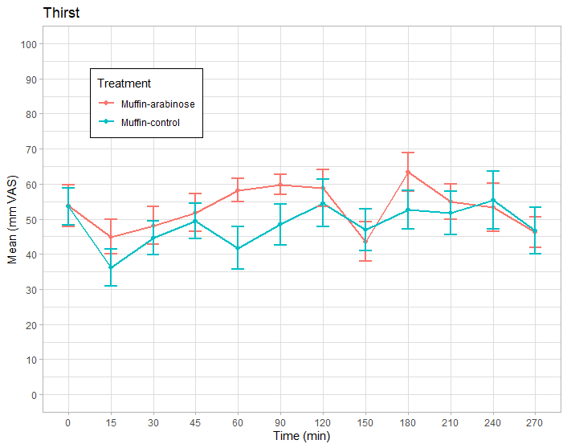 | 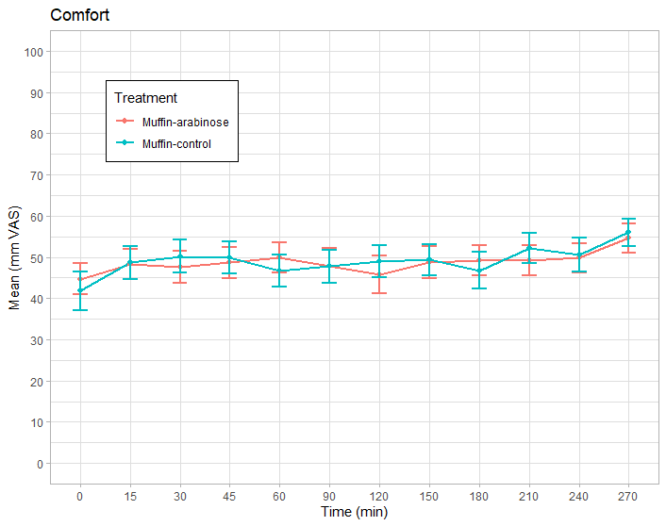
Figure S3. Subjective appetite feeling responses before and after consumption the muffins (n 15). At t=240 subjects received and ad libitum meal. Data are means, with standard errors represented by vertical bars.
Table S1. AUC of subjective appetite feelings (hunger, fullness, desire to eat, prospective food consumption and thirst).
 | - Fruit-based drinks (n 15)
 | Control |  |  | L-arabinose |  |  | D-xylose
 | Mean | SE |  | Mean | SE |  | Mean | SE |  | ANOVA: P*
Hunger | 17,098 | 885 |  | 16,772 | 1,051 |  | 15,892 | 964 |  | 0.21
Fullness | 9,005 | 719 |  | 8,189 | 718 |  | 8,817 | 427 |  | 0.65
Desire to eat | 18,264 | 811 |  | 17,801 | 885 |  | 17,502 | 915 |  | 0.47
Prospective consumption | 17,184 | 665 |  | 15,718 | 778 |  | 15,897 | 945 |  | 0.13
Thirst | 12,505 | 1,644 |  | 11,510 | 1,322 |  | 10,902 | 1,195 |  | 0.27
 | - Muffins (n 15)
 | Control |  |  | L-arabinose
 | Mean | SE |  | Mean | SE |  | ANOVA: P*
Hunger | 14,610 | 612 |  | 14,617 | 747 |  | 0.98
Fullness | 11,148 | 752 |  | 10,592 | 887 |  | 0.39
Desire to eat | 16,040 | 752 |  | 16,072 | 820 |  | 0.88
Prospective consumption | 14,163 | 861 |  | 14,810 | 891 |  | 0.19
Thirst | 13,481 | 1,484 |  | 13,950 | 1,510 |  | 0.39
* P-value for product effect derived from mixed model ANOVA.

Table S2. Food intake of the ad libitum meal served 240 minutes after consumption of the test products.
 | - Fruit-based drinks (n 15)
 | Control |  |  | L-arabinose |  |  | D-xylose
 | Mean | SE |  | Mean | SE |  | Mean | SE |  | ANOVA: P*
Intake (g) | 761 | 158 |  | 722 | 132 |  | 719 | 131 |  | 0.94
Intake (kcal) | 924 | 204 |  | 931 | 170 |  | 928 | 169 |  | 0.94
Intake (MJ) | 3.88 | 0.86 |  | 3.91 | 0.72 |  | 3.90 | 0.71 |  | 0.94
 | - Muffins (n 15)
 | Control |  |  | L-arabinose
 | Mean | SE |  | Mean | SE |  | ANOVA: P*
Intake (g) | 739 | 114 |  | 715 | 148 |  | 0.61
Intake (kcal) | 953 | 147 |  | 922 | 191 |  | 0.61
Intake (MJ) | 4.00 | 0.62 |  | 3.88 | 0.80 |  | 0.61
* P-value for product effect derived from mixed model ANOVA, p-values are identical as there was a mixed meal (542 kJ/100g).

