Supplementary materials:
Supplemental Fig. 1:
A

B
Artificial intelligence
H&E stain
1
5
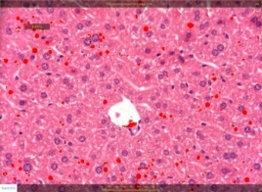
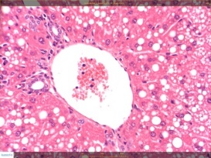
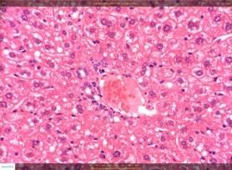
ND

6
2
HFCD

3
7
HFCD+F

8
4
HFCD+S

Supplemental Fig. 1: Effects of broccoli consumption on lipid content and liver histology. Male C57BL/6J mice were fed with normal diet (ND), high fat cholesterol diet (HFCD), high fat cholesterol diet+15% broccoli florets (HFCD+F), high fat cholesterol diet+15% broccoli stalks (HFCD+S) for seven weeks. Evaluation of Lipid content was performed by using the Folch method (A) Histological evaluation of the liver using H&E stain (B1-4) versus artificial intelligence (B5-8). Values are expressed as mean ±SEM (n=4-8).
Supplemental Table 1:
Group | AI  % fatty vacuoles  in hepatocytes | H&E stain  Grade of  hepatocytic  vacuolation
Normal diet | 4.13±0.53^{b} | 0.50±0.29^{b}
HFCD | 11.32±1.09ª | 2.50±0.50ª
HFCD + 15% (w/w) dietary broccoli florets | 11.75±2.67ª | 3.25±0.50ª
HFCD + 15% (w/w) dietary broccoli stalks | 10.41±1.15^{ab} | 3.25±0.50ª

Supplemental Table 1: Effect of broccoli supplementation on histology section of the perilobular region of the liver. Male C57BL/6J mice were fed with normal diet (ND), high fat cholesterol diet (HFCD), high fat cholesterol diet+15% broccoli florets (HFCD+F), high fat cholesterol diet+15% broccoli stalks (HFCD+S) for seven weeks. Values are expressed as mean ±SEM (n=4). Means without a common letter are statistically different (p<0.05).

