Supplementary material

Supplementary Figure 1

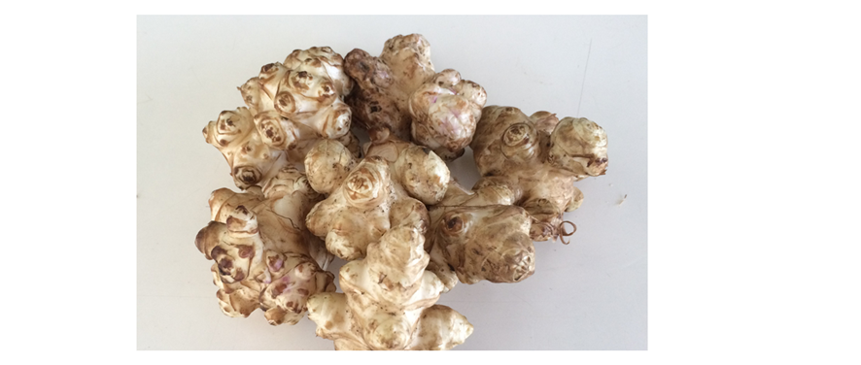
A strain of Jerusalem artichoke (Kikuimo in Japanese), “Sunflower Potato” was harvested in Saga prefecture and tubers were used for all the trials in the present study.

Supplementary Figure 2

Effect of Jerusalem artichoke on glucose metabolism in Trial 3, following the ingestion of a fat-rich meal. Jerusalem artichoke was administered prior to the meal or not (control) and the subsequent plasma (A) glucose and (B) insulin concentrations were compared. Black dot and line: control meal; red dot and line: meal plus Jerusalem artichoke. Data are means and standard deviations. *p<0.05, according to the Wilcoxon signed rank test. Abbreviation: JA, Jerusalem artichoke.

