Fig S1. Serum levels of triglycerides (TG), total cholesterol (TC), high-density lipoprotein (HDL), and low-density lipoprotein (LDL).
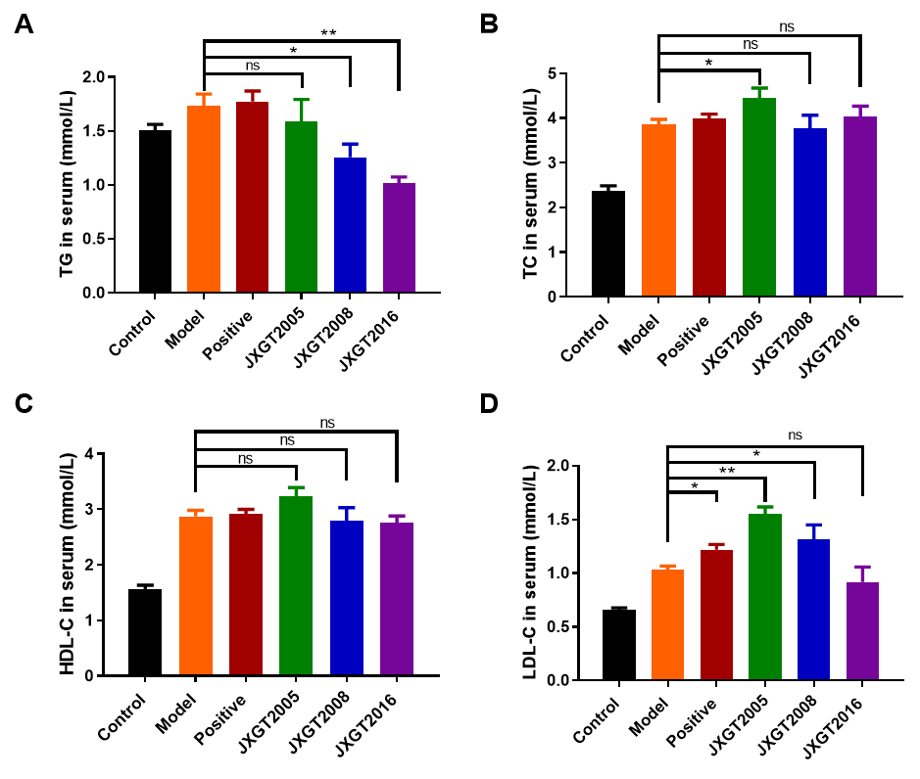
Data are presented as the means ± SD (n=8). **P < 0.01, and *P < 0.05.

