Figure Captions
Fig. S1. Gas chromatogram of short-chain fatty acids in standard solution (20 mmol/L).
Fig. S2. HPLC chromatogram of bile acids (BAs) in standard solution.

Figure S1
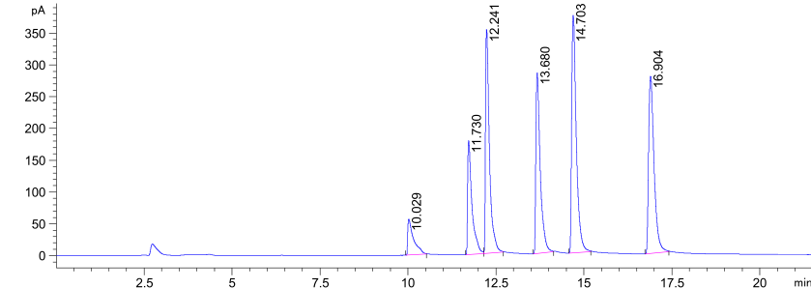

Figure S2

Table S1 The ingredient compositions of the experimental diets (g/kg Diet)
Ingredients | NC | HF
Corn starch | 549.5 | 449.5
Lard | 0 | 100
Soybean oil | 40 | 40
a AIN-76 mineral mixture (%mixture) | 35 | 35
Casein | 200 | 200
b AIN-76 vitamin mixture (%mixture) | 10 | 10
Sucrose | 100 | 100
L-cystine | 3 | 3
Cellulose | 50 | 50
Choline Chloride | 2.5 | 2.5
Cholesterol | 10 | 10

Table S2 Calibration curves of different short-chain fatty acids (SCFAs) in standard solution
SCFAs | Linear equation | Correlation coefficient (R²)
Acetic acid | y=62.583x-795.68 | 0.9914
Propionic acid | y=121.56x-1144.4 | 0.9963
i-butyric acid | y=171.47x-942.01 | 0.9988
n-butyric acid | y=171.6x-1250.1 | 0.998
i-valeric acid | y=193.82x-893.63 | 0.9996
n-valeric acid | y=204.8x-843.75 | 0.9997

Table S3 Calibration curves of different Bile acids (BAs) in standard solution
Bile acid | Full name | Retention time（min） | linear equation | Correlation coefficien（R）
LCA | Lithocholic acid | 32.49 | Y=-1219.6 + 2452.7*X | 0.996509278
β-UDCA | 3β-Ursodeoxycholic acid | 20.61 | Y=-826.9 + 8195.7*X | 0.997482682
DCA | Deoxycholic acid | 27.88 | Y=3170.5 + 6339.8*X | 0.998563291
CDCA | Chenodeoxycholic acid | 27.3 | Y=-1829.4 + 3711.6*X | 0.995607743
HDCA | Hyodeoxycholic acid | 22.6 | Y=299.04 + 3227*X | 0.997026219
α-MCA | α-Muricholic acid | 15.84 | Y=-108.95 + 4376.1*X | 0.995819998
UCA | Ursocholic acid | 13.32 | Y=-447.66 + 1843.2*X | 0.997831515
β-MCA | β-Muricholic acid | 17.28 | Y=132.52 + 1879.9*X | 0.996643952
CA | Cholic acid | 21.65 | Y=1176.8 + 2948.6*X | 0.999327695
TLCA | Taurolithocholic acid Sodium Salt | 24.44 | Y=-496.67 + 12631*X | 0.998144375
TDCA | Taurodeoxycholic acid Sodium Salt | 18.92 | Y=285.19 + 9813*X | 0.99745871
TCDCA | Taurochenodeoxycholic acid | 17.56 | Y=-296.28 + 8556.7*X | 0.998502153
TCA | Taurocholic acid Sodium Salt | 12.96 | Y=-68.605 + 4988.1*X | 0.999233726
T-α-MCA | Tauro-α-muricholic acid Sodium Salt | 7.391 | Y=305.65 + 8644.9*X | 0.995792518
T-β-MCA | Tauro-β-muricholic acid Sodium Salt | 7.662 | Y=27.883 + 7597*X | 0.99666197

Table S4 Sequences of primers used for RT-qPCR
Gene | Forward | Reverse
β-actin | GACCCAGATCATGTTTGAGA | GCAGTAATCTCCTTCTGCATCC
Fxr | GTGACAAAGAAGCCGCGAAT | GCAGGGTGAGCGCGTTGTAAT
Fgf15 | AAGTGGAGTGGGCGTATTGT | AGTGGACCTTCATCCGACAC

