Supplementary Table
Table S1. Primers for gene expression using real-time PCR
Genes |  | Sequence (5’-3’) | Size (bp) | NCBI Gene ID
Hdac3 | Forward | ATGACCAGAGTTACAAGCACCT | 74 | NM_053448.2
 | Reverse | GATGCACGTCGGCTGATAGA
Foxo3 | Forward | CTCCCTGCGAGTGTCTATAACTTT | 71 | NM_001106395.1
 | Reverse | ATTCCTCCTCCTCCCTTCCAC
Ccnd1 | Forward | TCCGGAGACCGGTCGTAGAG | 171 | NM_171992.5
 | Reverse | CCGGTCGTTGAGGAGATTGG
Lgr5 | Forward | GTGAGCTGGATGGCAGGATG | 184 | NM_001106784.1
 | Reverse | GCATTTCCAGCAAGACGCAA
Pcna | Forward | CACGTATATGCCGGGACCTT | 88 | NM_022381.3
 | Reverse | TCCCCACTCGCAGAAAACTT
Gcg | Forward | GCCATTCACAGGGCACATTC | 113 | NM_012707.2
 | Reverse | GGCAATGTTGTTCCGGTTCC
Egf | Forward | GGTCCACCCATTGGCAAAAC | 118 | NM_012842.2
 | Reverse | CACGAATCCTTCCCGACACA
Igf1 | Forward | GGGACGTACCAAAATGAGCG | 159 | NM_001082477.2
 | Reverse | ACGAACTGAAGAGCGTCCAC
Yap1 | Forward | ATTTCGGCAGGCAATACGGA | 76 | XM_006242490.4
 | Reverse | GCTGCGGAGAGCTAATTCCT
Actb | Forward | CCCGCGAGTACAACCTTCTT | 83 | NM_031144.3
 | Reverse | CGCAGCGATATCGTCATCCA

Figure S1. EdU incorporation assay of IEC-6 cells. DNA synthesis of IEC-6 cells was measured by the EdU incorporation assay at 24 h after treatment with PBS, 1 μM IP3, 10 mM butyrate, and 10 mM butyrate+1 μM IP3. Cell nuclei were stained with Hoechst solution (blue).
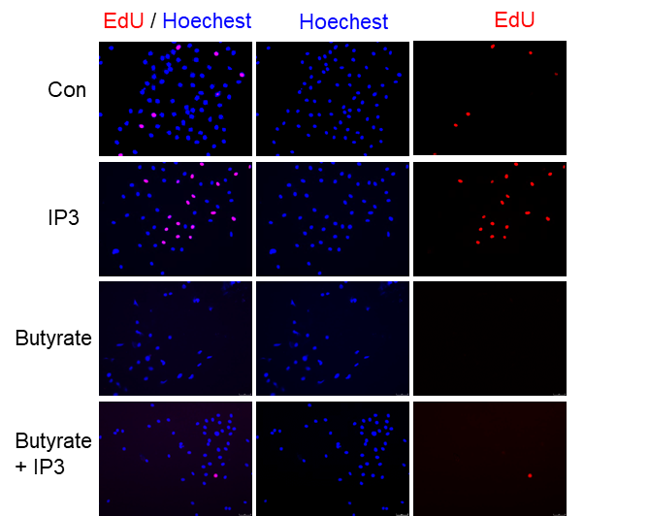

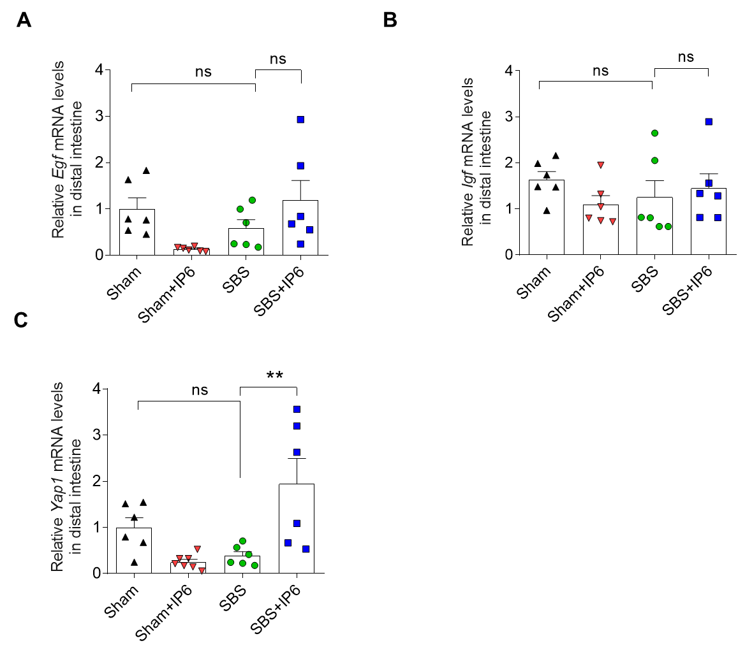
Figure S2. Gene expression altered by IP6. (A) The relative mRNA expression levels of Epidermal growth factor (Egf) in the distal small intestine (n = 6 per group). (B) The relative mRNA expression levels of Insulin like growth factor (Igf) in the distal small intestine (n = 6 per group). (C) The relative mRNA expression levels of Yes associated protein (Yap1) in the distal small intestine (n = 6 per group). Values were normalized to Actb expression. Values are mean ± SEM; one-way ANOVA with post-hoc Bonferroni’s multiple-comparison analysis was used for statistical analysis; ns, not significant; ** p < 0.01.

