Fig. 1.
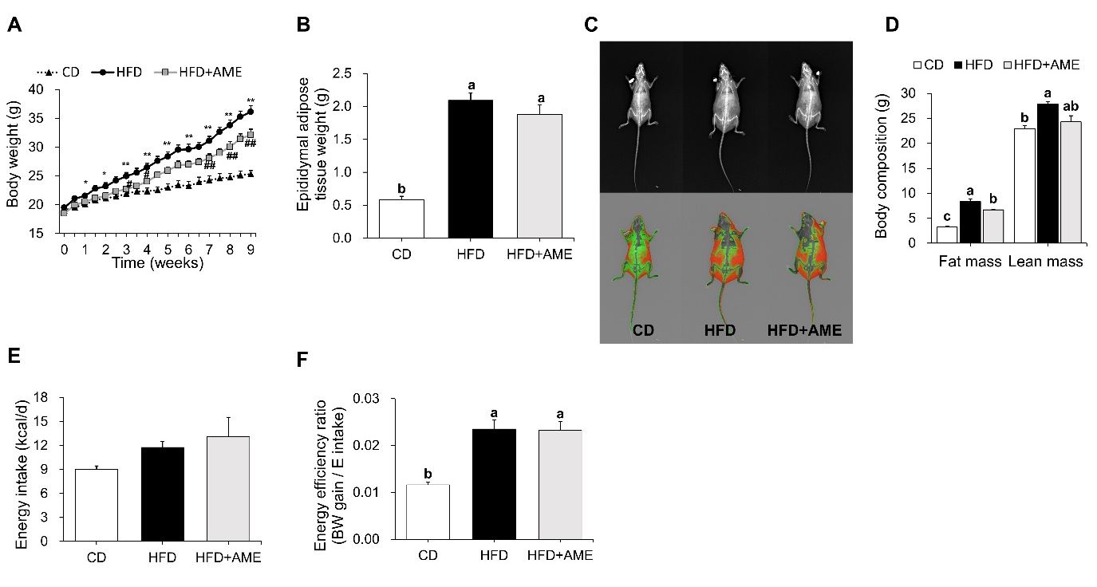
Table S2. Primer sequences used in quantitative real-time PCR
Gene¹ |  | Forward (5′→3′) | Reverse (5′→3′)
Adipogenesis | CEBPα | GGT TTA GGG ATG TTT GGG TTT TT | AAG CCC ACT TCA TTT CAT TGG T
 | CEBPβ | AGC GGC TGC AGA AGA AGG T | GGC AGC TGC TTG AAC AAG TTC
 | PPARγ | CCC ACC AAC TTC GGA ATC AG | AAT GCT GGA GAA ATC AAC TGT GGT A
Lipogenesis | FASN | ACA AGC AGA ATT TGT CCA CCT TTA A | TCT CTA GAG GGC TTG CAC CAA
 | SCD1 | TGC CCC TGC GGA TCT TC | TCG GGC CCA TTC GTA CAC
Inflammation | CD11C/ Itgax | CCA CTG TCT GCC TTC ATA TTC ATG | AAG ATG GCC CGG GTA CTC A
 | CD68 | TGG TGT AGC CTA GCT GGT CTG A | GGC TAT AAG CGG TCC TAG CAA GA
 | F4/80 | GGC CAT TGC CCA GAT TTT C | CGG TTG AGC AGA CAG TGA ATG A
 | IL-1Β | GCA ACT GTT CCT GAA CTC AAC T | ATC TTT TGG GGT CCG TCA ACT
 | IL-6 | TCG GAG GCT TAA TTA CAC ATG TTC | TGC CAT TGC ACA ACT CTT TTC T
 | MCP-1/ CCL2 | CTC TCT CTT CCT CCA CCA CCA T | CCA GCC GGC AAC TGT GA
 | NOS2 | CAG CTG GGC TGT ACA AAC CTT | CAT TGG AAG TGA AGC GTT TCG
 | TNF-Α | TGG CCT CCC TCT CAT CAG TT | CAG GCT TGT CAC TCG AAT TTT G
ER stress | ATF4 | GCT GAA AAA GAT GGA GCA AAA CA | TGC TCA GCC CGC TTC TTC T
 | CHOP | GCA TGA ACA GTG GGC ATC AC | CGA TGG TGC TGG GTA CAC TTC
 | GRP78/ Bip | ACC CTT ACT CGG GCC AAA TT | GCT TCA TGG TAG AGC GGA ACA
 | spliced XBP1 | CTG AGT CCG CAG CAG GT | TGT CAG AGT CCA TGG GAA GA
Endogenous control | 18s rRNA | AAC CCG TTG AAC CCC ATT | CCA TCC AAT CGG TAG TAG CG
¹ ATF4, Activating transcription factor 4; CD11C/Itgax, Integrin alpha X; CD68, CD68 antigen; CEBPα, CCAAT/enhancer binding protein alpha; CEBPβ, CCAAT/enhancer binding protein beta; CHOP, C/EBP homologous protein; F4/80, Adhesion G protein-coupled receptor E1; FASN, Fatty acid synthase; GRP78/Bip, 78-kDa glucose-regulated protein/binding immunoglobulin protein; IL-1β, Interleukin-1β; IL-6, Interleukin-6; SCD1, MCP-1/CCL2, monocyte chemotactic protein-1/ chemokine (C-C motif) ligand 2; NOS2, Nitric oxide synthase 2, inducible; Stearoyl-CoA desaturase-1; TNF-α, Tumor necrosis factor-α; PPARγ, Peroxisome proliferator-activated receptor γ; spliced XBP1, spliced X-box binding protein 1; 18s rRNA, 18s ribosomal RNA.
Table S3. List of antibodies used in western blotting analysis
Protein | Company | Product number
CHOP | Santa Cruz Biotechnology | #2895
eIF2α | Cell Signaling Technologies | #9722
phosphorylated eIF2α | Cell Signaling Technologies | #3398
HSC70 | Santa Cruz Biotechnology | #sc-7298
IL-6 | Santa Cruz Biotechnology | #sc-32296
JNK | Cell Signaling Technologies | #9252
phosphorylated JNK | Cell Signaling Technologies | #4668
NOS2 | Santa Cruz Biotechnology | #sc-7271
TNF-α | Santa Cruz Biotechnology | #sc-52746

