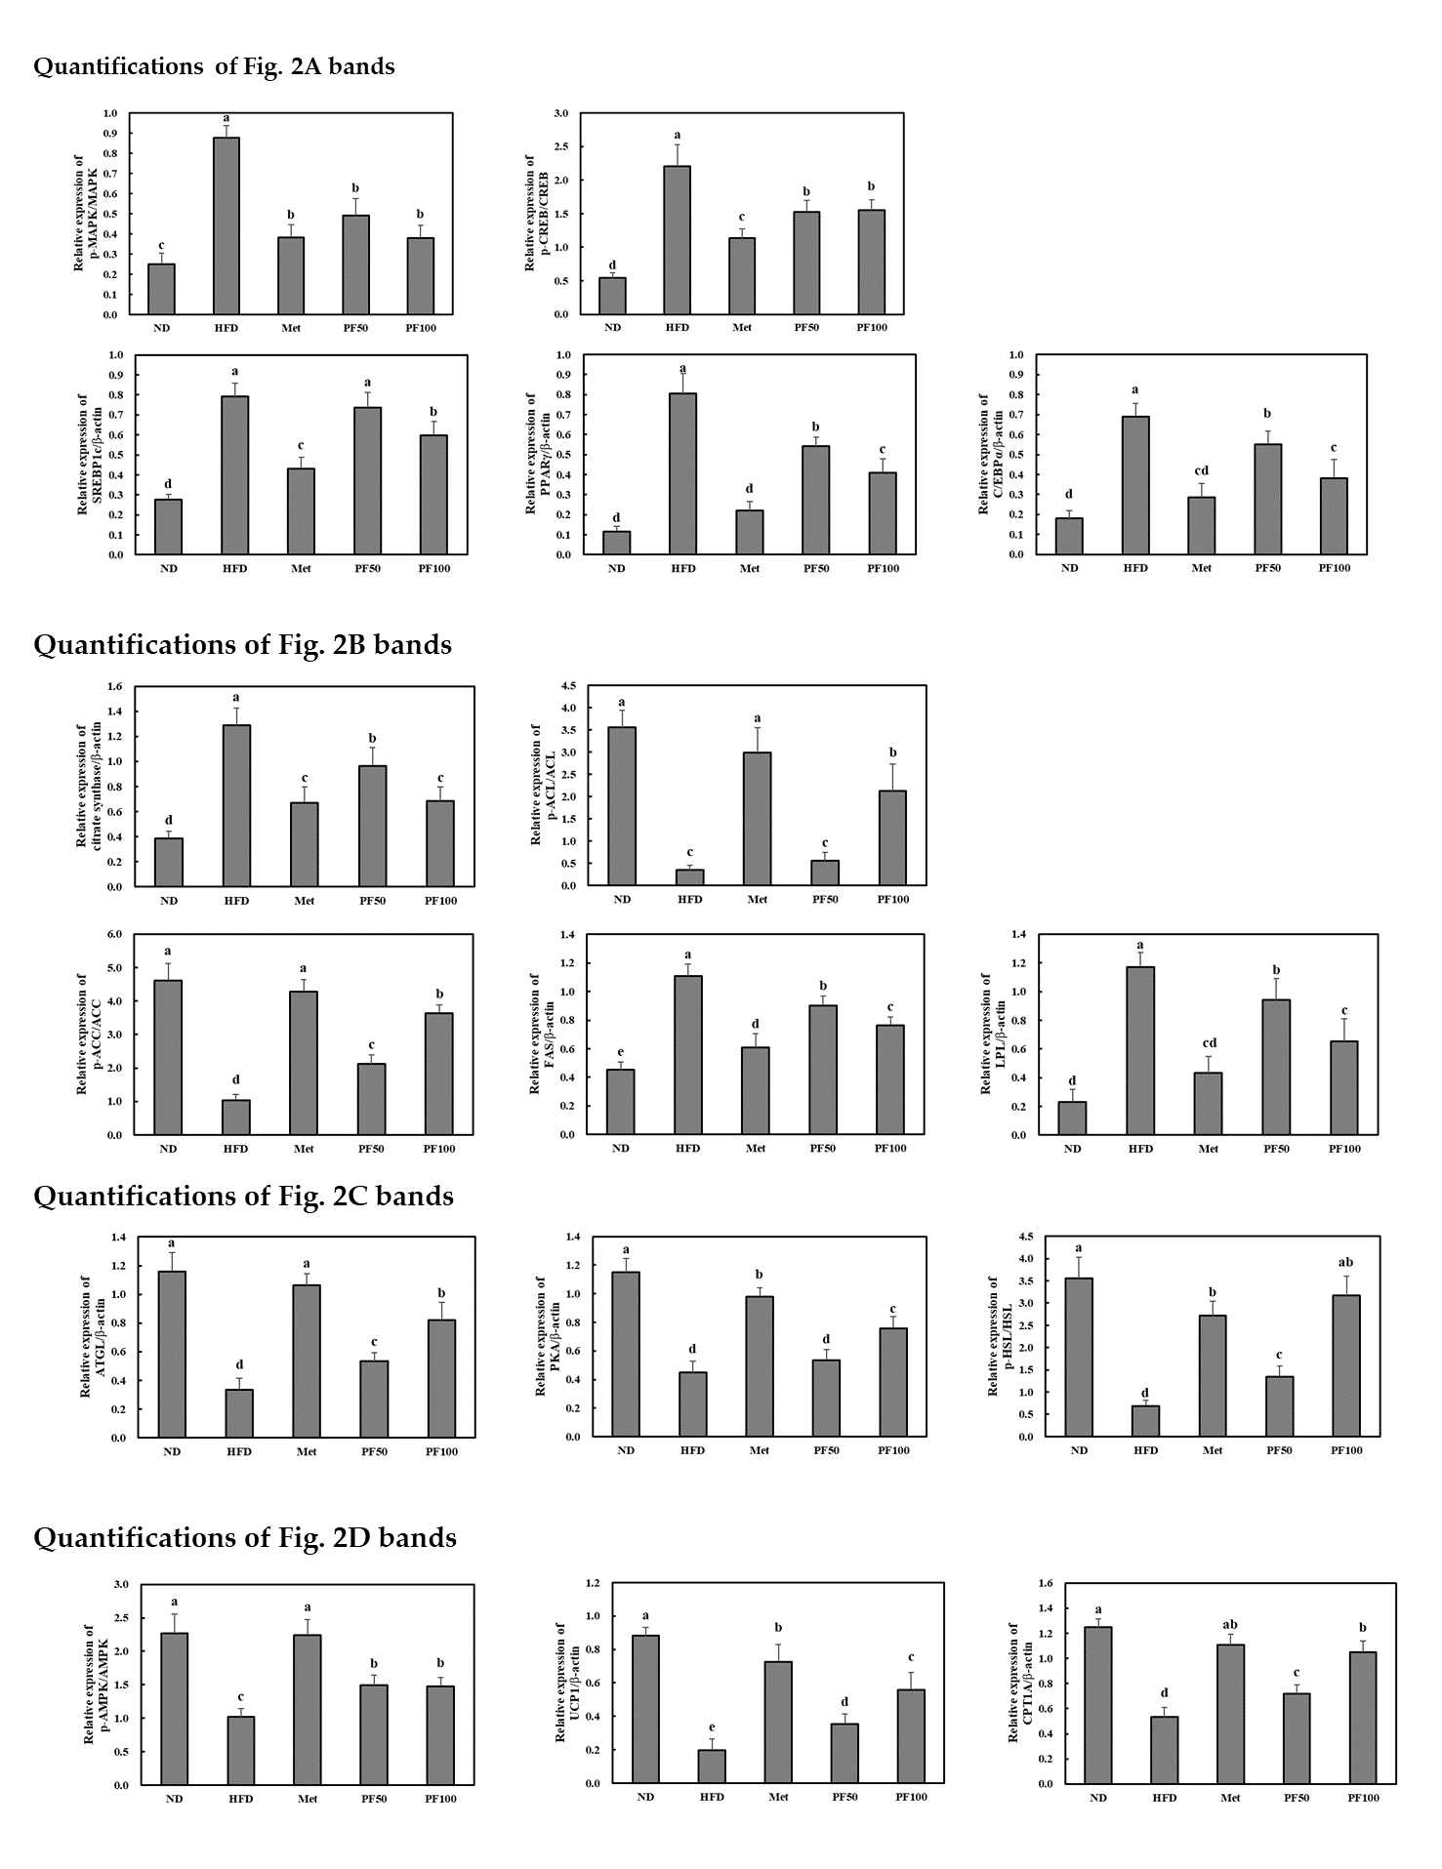
Sup 1. Quantification of the western blot bands relative expression in Figure 2.

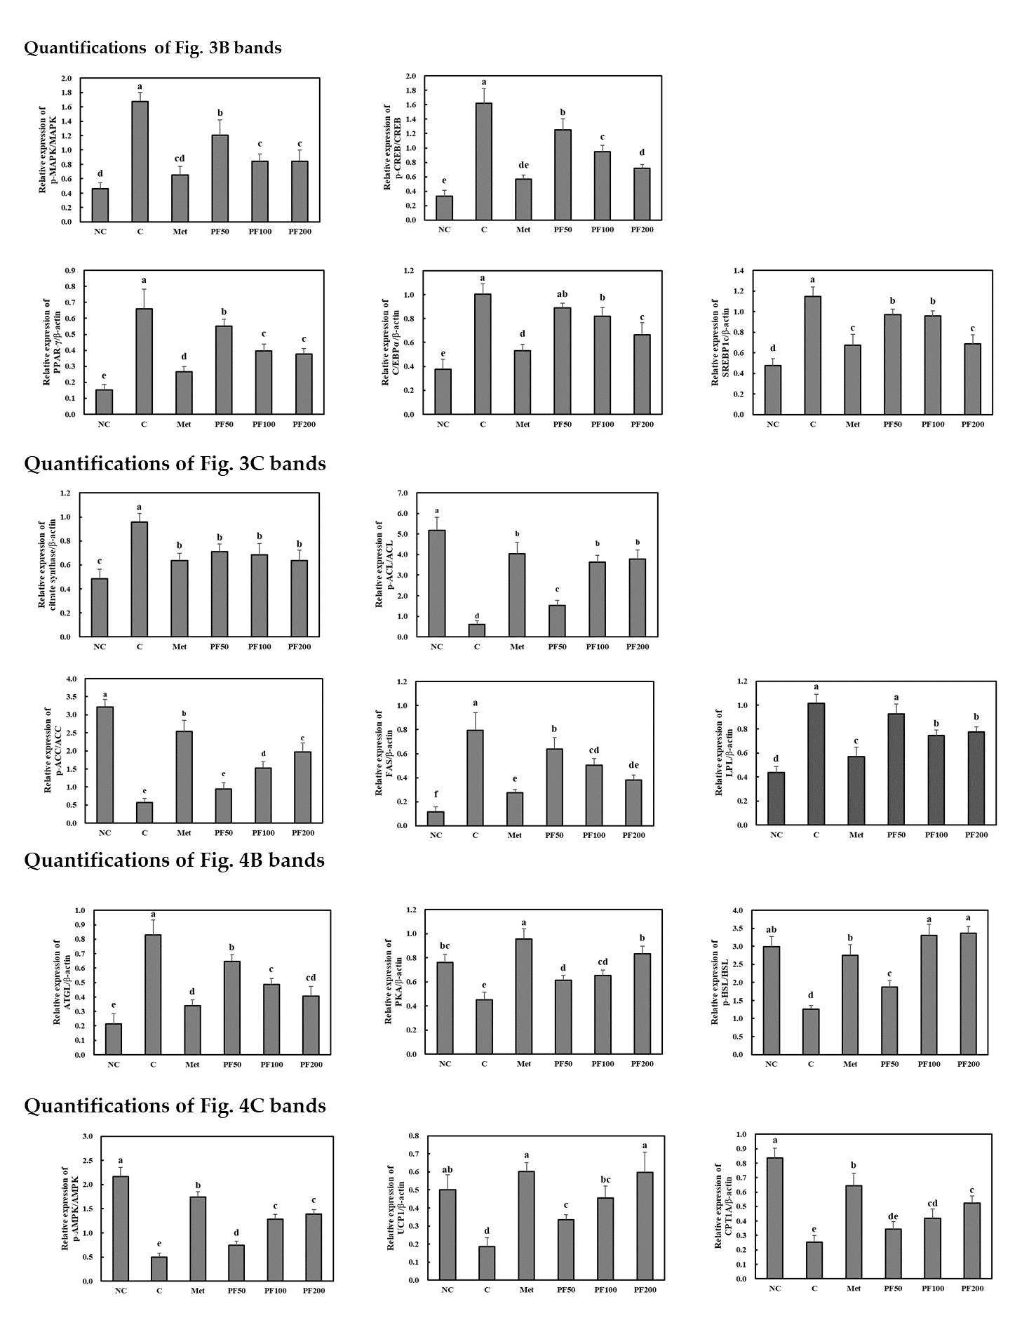
Sup 2. Quantification of the western blot bands relative expression in Figure 3 and 4.

