List of Supporting Information
Ear edema induced by xylene in mice
Table S1 Effects of Chukrasia tabularis on ear edema induced by xylene in mice.
Cytotoxicity bioassays
NMR and ESI-MS spectroscopic data
Table S2 ¹H-NMR(400 MHz) and ¹³C-NMR(100 MHz) spectral data of compounds1-3
Table S3 Cytotoxicity of compounds 2-16 against tested cell lines
Figure S1 Key HMBC and NOESY of compound 1
Figure S2 Calculated and experimental ECD spectra of 1-3.
Figure S3 ¹H NMR spectrum (400 MHz) of compound 1 in CDCl₃.
Figure S4 ¹³C NMR spectrum (100 MHz) of compound 1 in CDCl₃.
Figure S5 Key HMBC and NOESY of compound 2.
Figure S6 ¹H NMR spectrum (400 MHz) of compound 2 in CD₃OD.
Figure S7 ¹³C NMR spectrum (100 MHz) of compound 2 in CD₃OD.
Figure S8 Key HMBC and NOESY of compound 3.
Figure S9 ¹H NMR spectrum (400 MHz) of compound 3 in CD₃OD.
Figure S10 ¹³C NMR spectrum (100 MHz) of compound 3 in CD₃OD.
Ear edema induced by xylene in mice
Male ICR mice (18–20 g) were provided by the Laboratory Animal Center, Fujian Medical University. After intragastric administration of the extract or control for 1 hour, each mouse’s right ear was treated with 40 μL xylene solution, and the left ear was taken as the control. One hour after xylene treatment, the mice were sacrificed by cervical dislocation. The round part of each ear, with a diameter of 6mm, was weighed by an electronic analytical balance with an accuracy of 0.1 mg, and the inhibitory effect on ear edema was calculated. The weight difference of two plugs was used to measure the edema response (Table S1). Animal care and use complied with institutional guidelines, and the program was affirmed by the Experimental Animal Management Committee of Fujian Medical University.
Table S1 Effects of Chukrasia tabularis on ear edema induced by xylene in mice.
Extracts/Fractions | Dose (mg/kg) | Edema Degree (±SD, mg) | Inhibition Rate (%)
Control group |  | 7.83±0.36
Aspirin | 200 | 4.99±0.30* | 36.30
Methanol extract | 400 | 5.30±0.36* | 32.27
Petroleum ether fraction | 400 | 5.12±0.59* | 34.62
Dichloromethane fraction | 400 | 4.48±0.25* | 42.78
Ethyl acetate fraction | 400 | 4.70±0.34* | 40.03
n-Butanol fraction | 400 | 5.26±0.24* | 32.84
*P < 0.01 vs. Control group
Table S2 ¹H-NMR(400 MHz) and ¹³C-NMR(100 MHz) spectral data of compounds1-3
No. | 1ª |  | 2^{b} |  | 3^{b}
 | δH (J inHz） | δC | δH (J inHz） | δC | δH (J inHz） | δC
1 |  | 86.9 |  | 86.9 |  | 87.5
2 |  | 79.7 |  | 79.5 |  | 81.0
3 | 4.19(s) | 82.7 | 4.63 (s) | 83.2 | 4.51 (s) | 84.7
4 |  | 45.4 |  | 45.5 |  | 46.1
5 | 2.46 (dd, 12.8, 5.8) | 37.1 | 2.90 (dd, 14.4, 7.3) | 37.2 | 2.21 (m) | 39.6
6 | 2.10(m) | 34.0 | 2.62 (dd, 15.9, 7.6) | 34.4 | 2.84(dd, 14.0, 7.1) | 36.9
 | 2.16(m) |  | 2.91 (dd, 15.9, 7.6) |  | 2.91 (m)
7 |  | 169.4 |  | 172.8 |  | 173.9
8 |  | 86.0 |  | 86.0 |  | 86.4
9 |  | 85.5 |  | 85.5 |  | 86.1
10 |  | 45.3 |  | 45.5 |  | 45.6
11α | 1.34(m) | 25.3 | 1.75 (m) | 25.4 | 1.72 (m) | 25.4
11β | 1.82(m) |  | 2.16 (m) |  | 2.14 (m)
12α | 1.34(m) | 29.8 | 2.31 (m) | 27.9 | 1.29 (m) | 29.8
12β | 1.38(m) |  | 2.52 (m) |  | 1.31 (m)
13 |  | 33.8 |  | 33.9 |  | 33.7
14 | 1.73(m) | 42.5 | 2.15 (m) | 45.4 | 2.19 (m) | 45.6
15α | 2.30(dd, 17.2, 10.6) | 26.4 | 2.80(dd, 16.9, 4.8) | 26.6 | 2.39 (dd, 17.2, 5.2) | 27.3
15β | 2.79(dd, 17.2, 10.6) |  | 3.15(dd, 16.9, 4.8) |  | 3.12 (m)
16 |  | 169.4 |  | 169.4 |  | 170.5
17 | 5.11(s) | 78.4 | 5.60(s) | 78.5 | 5.38 (s) | 80.3
18 | 0.72(s) | 19.9 | 1.14(s) | 19.9 | 1.13 (s) | 17.8
19 | 0.77(s) | 16.4 | 1.16 (s) | 16.5 | 1.19 (s) | 15.9
20 |  | 164.0 |  | 134.3 |  | 130.1
21 | 5.79(s) | 97.7 |  | 163.9 |  | 171.1
22 | 5.83(s) | 122.0 | 7.29 (s) | 149.9 | 6.30 (s) | 122.4
23 |  | 169.1 | 6.20 (d, 5.4) | 97.7 | 6.00 (d, 5.6) | 104.1
28 | 0.51(s) | 14.5 | 0.90 (s) | 14.6 | 0.89 (s) | 13.9
29a | 1.30(d, 10.8) | 39.6 | 1.63 (d, 10.8) | 39.7 | 1.65 (d, 10.6) | 36.9
29b | 1.55(d, 10.8) |  | 1.96 (d, 10.8) |  | 1.95 (d, 10.6)
30 | 5.42(s) | 70.4 | 5.87(s) | 70.7 | 5.79 (s) | 71.5
31 |  | 119.2 |  | 119.2 |  | 119.6
32 | 1.25(s) | 21.2 | 1.68 (s) | 21.2 | 1.62 (s) | 20.4
1´ |  | 177.1 |  | 177.4 |  | 178.4
2´ | 2.50(m) | 34.7 | 6.29 (d, 5.4) | 122.2 | 2.27 (m) | 27.9
3´ | 0.65 (d, 6.5) | 18.1 | 7.27 (d, 4.9) | 163.8 | 2.49 (m) | 32.3
4´ | 0.67 (d, 6.5) | 19.5 | 2.16 (m) | 42.7 | 0.93 (d, 6.9) | 14.0
5´ |  |  | 1.14 (d, 7.1) | 18.1 | 0.93 (d, 6.9) | 14.0
6´ |  |  | 1.19 (d, 7.1) | 20.4
1´´ |  | 175.1 |  | 175.1 |  | 175.9
2´´ | 2.13(m) | 34.7 | 1.67 (q, 7.3) | 28.9 | 2.30 (q, 7.3) | 27.9
3´´ | 0.73 (d, 6.5) | 20.2 | 1.08 (t, 7.3) | 8.8 | 1.04 (t, 7.3) | 8.2
4´´ | 0.76 (d, 6.5) | 20.4
OMe-7´ | 3.33(s) | 53.0 | 3.75(s) | 53.0 | 3.67 (s) | 56.8
ª Recorded in CDCl₃, ^{b} Recorded in CD₃OD

Cytotoxicity bioassays
Huh-7 (hepatoma), MCF-7 (human breast), KB (oral epithelial), Hela (cervical), H460 (lung), A-549 (lung), and HepG2 (hepatocellular) cancer cell lines (provided by Shanghai Cell Bank) were maintained in RPMI 1640 at 37 ℃, supplemented with 10% FBS. Cytotoxicity was determined by the SRB method, with 5-fluorouracil (5-FU) as a positive control. The IC₅₀ value was calculated using the GraphPad prism program.
Table S3 Cytotoxicity of compounds 2-16 against tested cell lines (μM) ª
Compounds | IC₅₀ (μM)
Compounds | Huh-7 | HepG2 | KB | H460 | Hela | A549 | MCF-7
2 | 72.09±13.45 | 69.37±10.56 | 39.23±2.17 | 60.78±6.96 | 33.17±8.41 | 54.67±10.08 | 23.38±5.81
3 | >100 | 99.37±10.56 | >100 | >100 | >100 | >100 | >100
5 | >100 | 78.03±12.66 | >100 | >100 | >100 | >100 | >100
6 | 29.58±7.69 | 59.32±4.67 | 35.13±5.07 | 35.13±5.07 | 29.32±7.11 | 43.62±10.55 | >100
7 | 94.67±12.53 | >100 | 40.88±6.56 | >100 | 58.36±9.09 | >100 | >100
9 | 59.54±13.11 | 44.32±6.00 | 56.58±8.30 | 59.54±13.11 | 59.98±4.19 | 65.99±10.08 | >100
11 | 79.76±9.24 | 79.98±5.26 | 63.52±8.25 | 73.16±10.46 | 86.33±9.28 | 45.05±6.33 | 52.60±7.20
5-Fluorouracil^{b} | 36.16±4.17 | 30.49±1.54 | 19.50±1.24 | 13.69±2.85 | 2.31±0.98 | 36.16±1.73 | 23.44±1.22
ª Compounds 4, 8, 10 and 12-16 were inactive against all cell lines tested (IC₅₀>100μM). ^{b} Positive control

NMR and ESI-MS spectroscopic data
Phragmalin A (1): White powder; [α]²⁸_{D}: -1.00 (c 2.39, CHCl₃); UV (MeOH)210 nm; IR (KBr): ν_{max} 3498, 2969, 1741, 1696, 1260, 1068 cm⁻¹; The ¹H and ¹³CNMR data, listed in Table S2; HRESI-MS m/z 731.2919 [M-H]⁺ (calcd. for C₃₇H₄₇O₁₅,731.2914).
Chukrasin F (2): [α]²⁸_{D}: -0.26 (c 0.40, CHCl₃); UV (MeOH) 210 nm; IR (KBr): ν_{max} 3565, 2973, 1743, 1720, 1271, 1047 cm⁻¹; The ¹H and ¹³CNMR data, listed in Table S2; HRESI-MS m/z 745.3094 [M+H]⁺ (calcd. for C₃₈H₄₉O₁₅, 745.3070).
Chukrasin G (3): [α]²⁸_{D}: -0.13 (c 0.24, CHCl₃); UV (MeOH) 210 nm; IR (KBr): ν_{max} 3560, 2971, 1746, 1696, 1211, 1056 cm⁻¹; The ¹H and ¹³CNMR data, listed in Table S2; HRESI-MS m/z 756.2918 [M+Na+H]⁺ (calcd. for C₃₇H₄₉O₁₅, 756.2968).

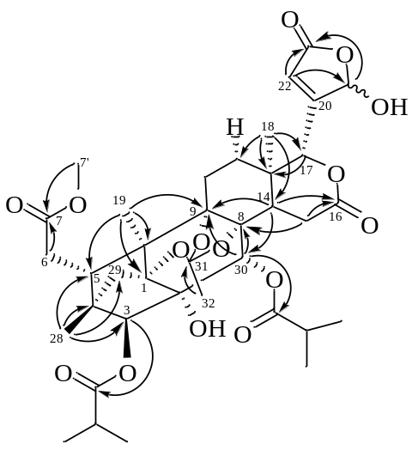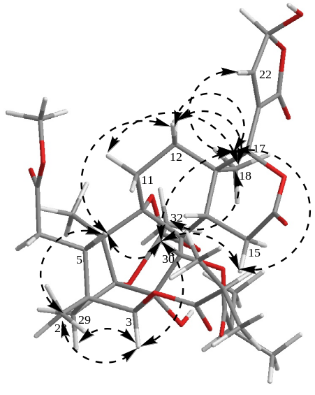
Figure S1 Key HMBC and NOESY of compound 1

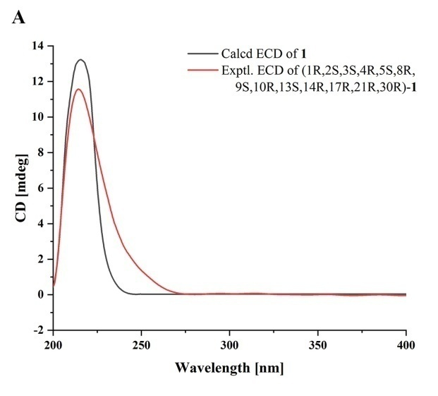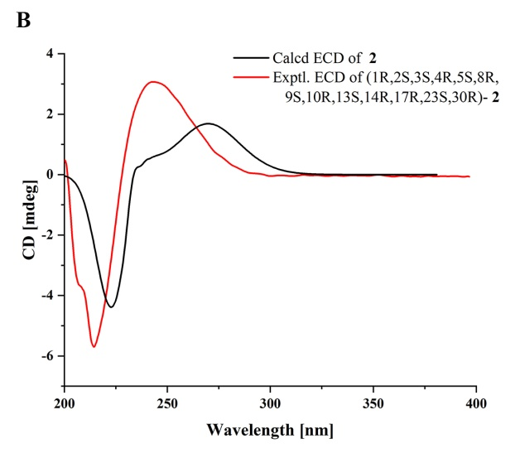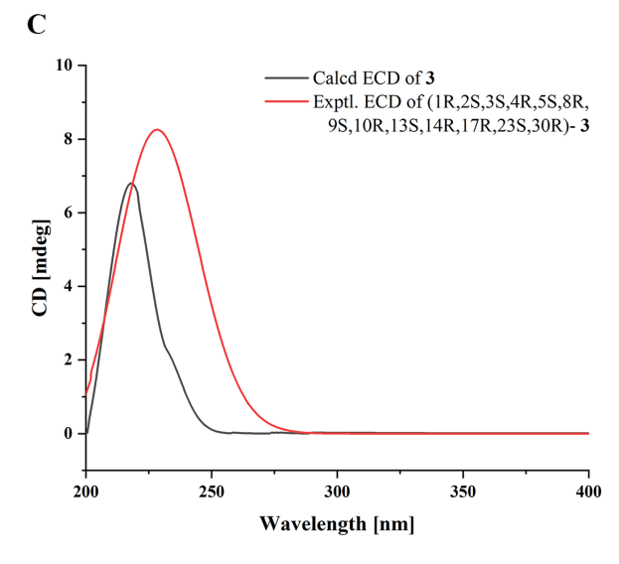
Figure S2 Calculated and experimental ECD spectra of 1-3.
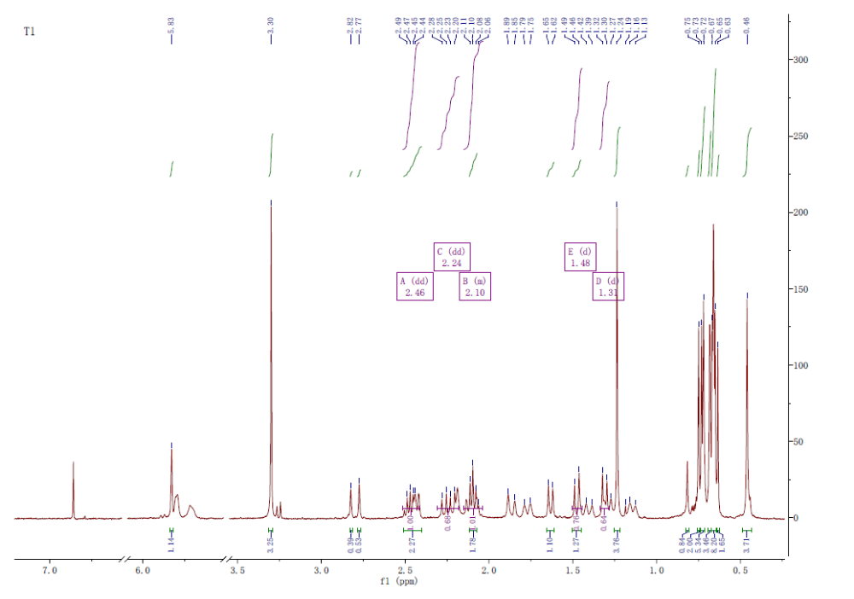
Figure S3 ¹H NMR spectrum (400 MHz) of compound 1 in CDCl₃.

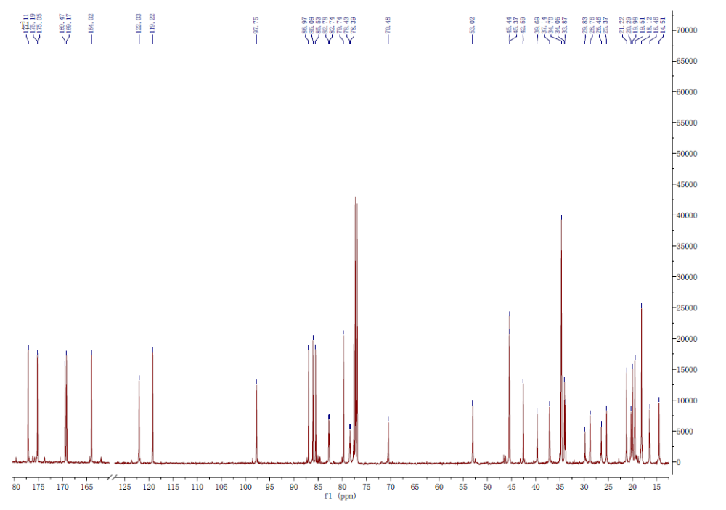
Figure S4 ¹³C NMR spectrum (100 MHz) of compound 1 in CDCl₃.

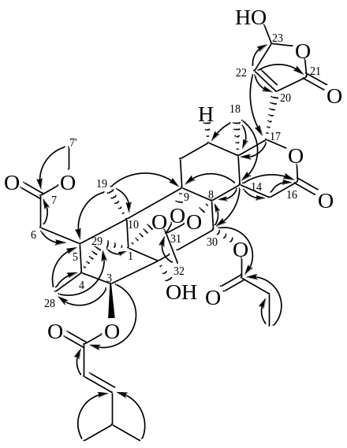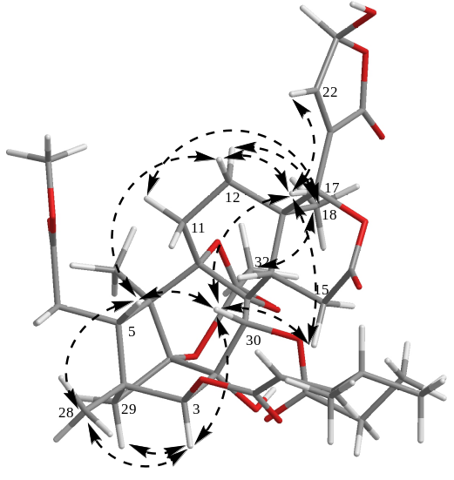

Figure S5 Key HMBC and NOESY of compound 2.
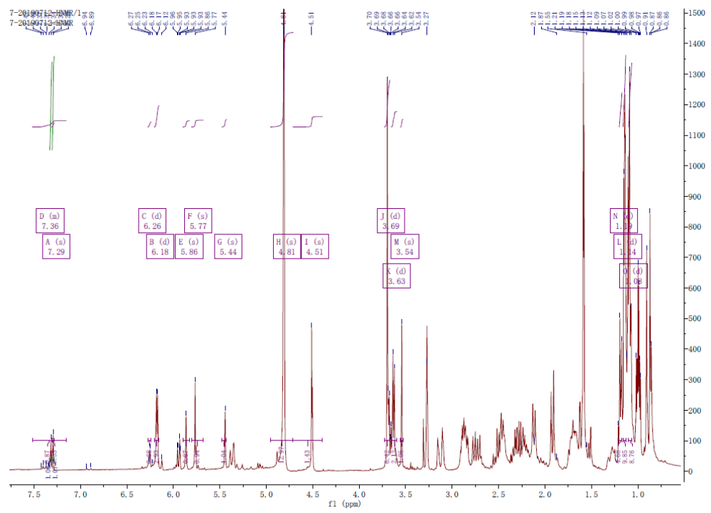
Figure S6 ¹H NMR spectrum (400 MHz) of compound 2 in CD₃OD.
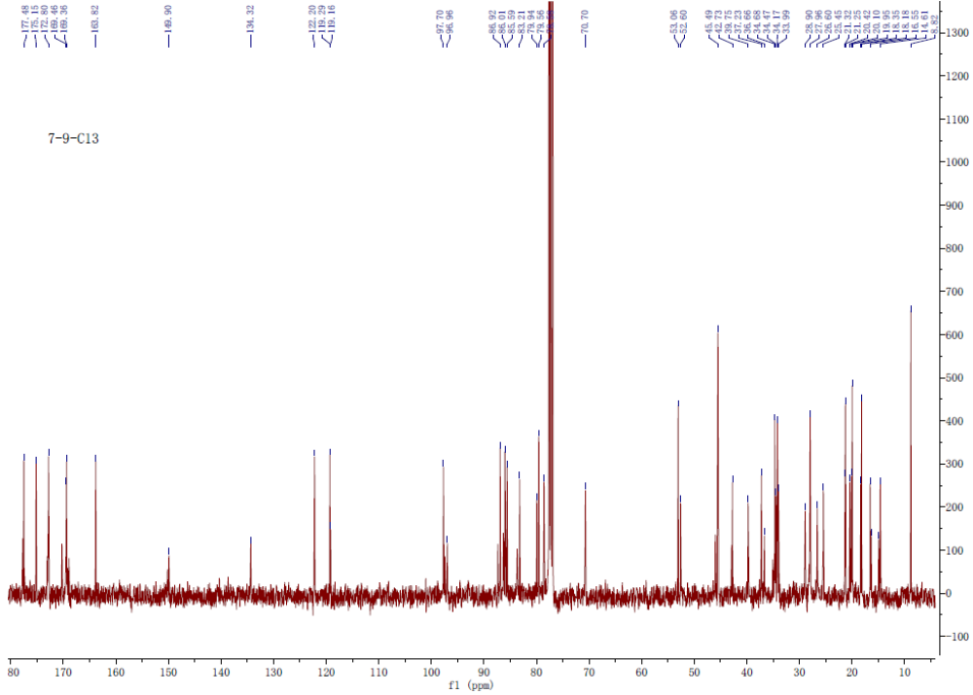
Figure S7 ¹³C NMR spectrum (100 MHz) of compound 2 in CD₃OD.

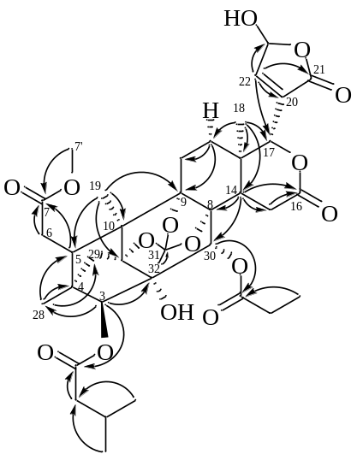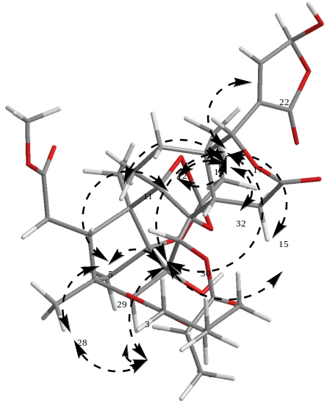

Figure S8 Key HMBC and NOESY of compound 3.
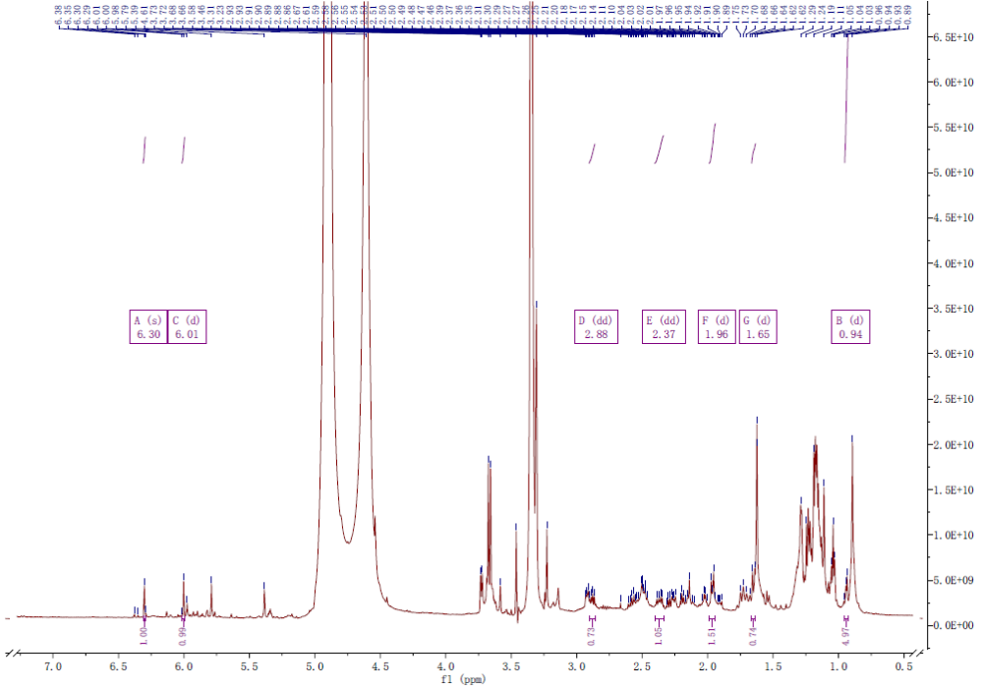
Figure S9 ¹H NMR spectrum (400 MHz) of compound 3 in CD₃OD.
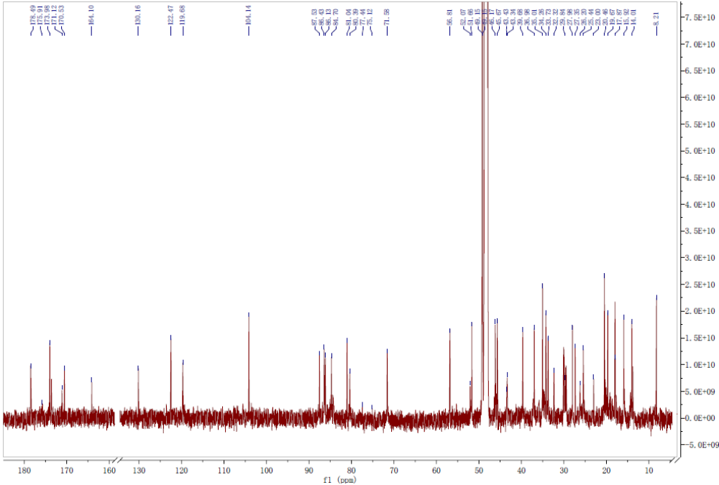
Figure S10 ¹³C NMR spectrum (100 MHz) of compound 3 in CD₃OD.

