Supplements

Supplement 1. The Flow chart.
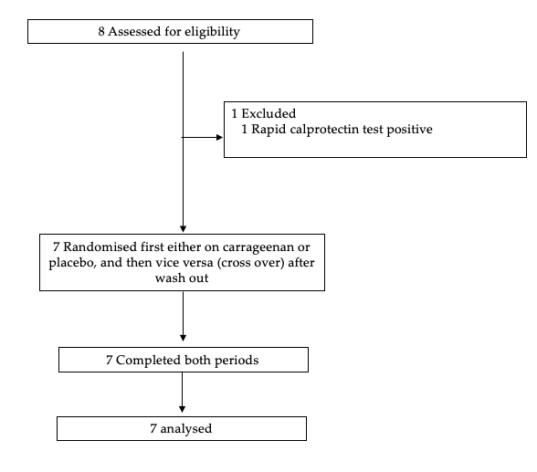
Supplement 2. Simple Clinical Colitis Activity Index, Finnish questionnaire
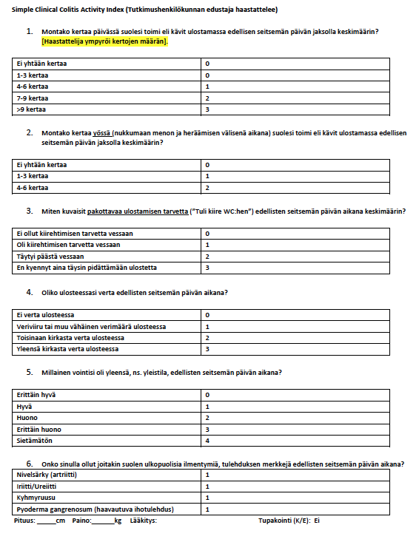

Supplement 3. List of food items containing carrageenan, to be avoided (in Finnish).

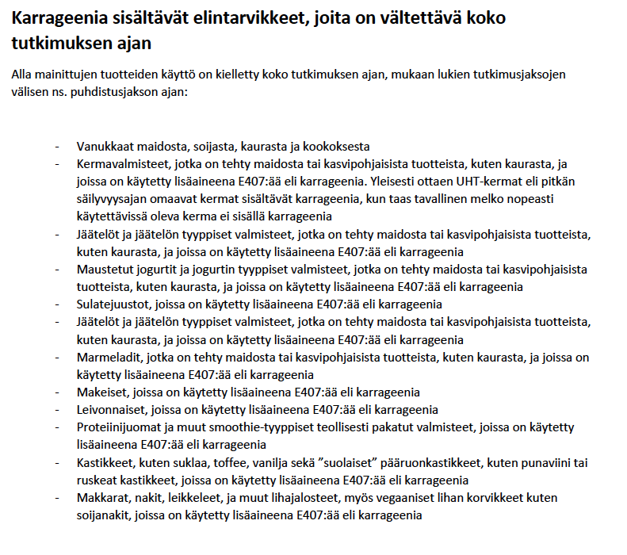

Supplement 4. Pre-packed pouches containing carrageenan (0) and placebo (oat fiber, high in beta-glucan). 0 and 00 samples were provided during different study visits so that the participants were not able to compare packages at the same time.

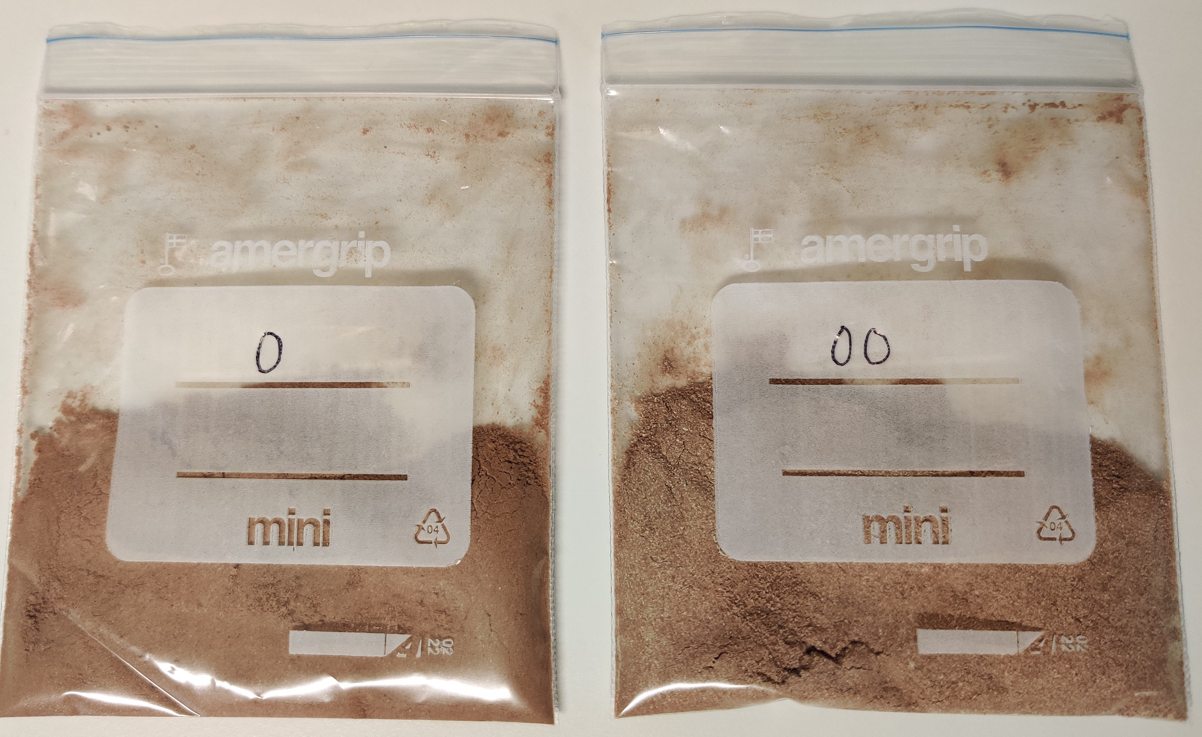

Supplement 5. Dietary intakes during the intervention (n=6).

 | Placebo (average, sd) | Carrageenan (average, sd) | p-value*
Energy, Kj | 8412 (1492) | 8519 (1254) | 0.869
Carbohydrate, grams | 207 (39) | 218 (33) | 0.556
Protein, grams | 90 (7.9) | 88 (17) | 0.600
Fat, grams | 83 (20) | 81 (12) | 0.772
Fiber, grams | 24 (5.3) | 24 (6.5) | 0.884
*) paired sample t-test for all other nutrients except for protein, in which Wilcoxon signed rank test was used due to nonparametric distribution of protein intakes

